3GPP TS 32.296 V11.3.0 (2012-03)
Technical Specification
3rd Generation Partnership Project;
Technical Specification Group Services and System Aspects;
Telecommunication management;
Charging management;
Online Charging System (OCS): Applications and interfaces
(Release 11)

The present document has been developed within the 3rd Generation Partnership Project (3GPP TM) and may be further elaborated for the purposes of 3GPP.
The present document has not been subject to any approval process by the 3GPP Organizational Partners and shall not be implemented.
This Specification is provided for future development work within 3GPP only. The Organizational Partners accept no liability for any use of this Specification.
Specifications and reports for implementation of the 3GPP TM system should be obtained via the 3GPP Organizational Partners' Publications Offices.

Keywords
GSM, UMTS, LTE, charging, management
3GPP
Postal address

3GPP support office address
650 Route des Lucioles - Sophia Antipolis
Valbonne - FRANCE
Tel.: +33 4 92 94 42 00 Fax: +33 4 93 65 47 16
Internet
http://www.3gpp.org
Copyright Notification
No part may be reproduced except as authorized by written permission.
The copyright and the foregoing restriction extend to reproduction in all media.

© 2012, 3GPP Organizational Partners (ARIB, ATIS, CCSA, ETSI, TTA, TTC).
All rights reserved.

UMTS™ is a Trade Mark of ETSI registered for the benefit of its members
3GPP™ is a Trade Mark of ETSI registered for the benefit of its Members and of the 3GPP Organizational Partners
LTE™ is a Trade Mark of ETSI currently being registered for the benefit of its Members and of the 3GPP Organizational Partners
GSM® and the GSM logo are registered and owned by the GSM Association
Contents
Foreword 6
1 Scope 7
2 References 7
3 Definitions, symbols and abbreviations 9
3.1 Definitions 9
tariff: set of parameters defining the network utilization charges for the use of a particular bearer / session / service 9
3.2 Symbols 9
3.3 Abbreviations 10
4 Required functionality of the OCS 11
5 Architectural concept 12
5.1 Architecture reference model for online charging 12
5.2 Functions within the OCS 15
5.2.1 Online Charging Functions 15
5.2.1.1 Event Based Charging Function 15
5.2.1.2 Session Based Charging Function 15
5.2.2 Rating Function 16
6 Functionalities and Message Flows 17
6.1 Reference Point Required Functionality 17
6.1.1 Re Reference Point (EBCF, SBCF - Rating Function) 17
6.1.1.1 Functionality for class "A" Rating Function 17
6.1.1.1.1 Class "A" Counter Handling 18
6.1.1.2 Functionality for class "B" Rating Function 19
6.1.2 Rc Reference Point (EBCF, SBCF - Account Balance Management Function) 19
6.2 Re Message Flows 20
6.2.1 Class "A" Rating Function Message Flows 21
6.2.1.1 PriceRequest method 21
6.2.1.1.1 PriceRequest scenario with Immediate Charging 21
6.2.1.1.2 PriceRequest scenario with Unit Reservation 23
6.2.1.2 TariffRequest method 25
6.2.1.2.1 Basic TariffRequest scenario 26
6.2.1.2.2 TariffRequest Scenario with multiple Tariff Switches and Expiry Time 28
6.2.1.2.3 TariffRequest Scenario with limited validity 32
6.2.1.2.4 TariffRequest Scenario with unsolicited changes of session parameters 35
6.2.2 Class "B" Rating Function Message Flows 37
6.2.2.1 PriceRequest method 37
6.2.2.1.1 PriceRequest scenario with Immediate Charging 37
6.2.2.1.2 PriceRequest scenario with Unit Reservation 39
6.2.2.2 TariffRequest method 41
6.2.2.2.1 TariffRequest scenario with successful service delivery 41
6.2.2.2.2 TariffRequest scenario with service denial or unsuccessful delivery 45
6.2.2.3 ServiceUsageRequest with reservation method 47
6.3 Sy Message Flows 50
7 Definition of charging information 51
7.1 Re Message Types and Formats 51
7.1.1 General guidelines 51
7.1.1.1 General Description of Data types and Message Formats 51
7.1.1.2 Rating Function Class selection 51
7.1.2 Methods 51
7.1.2.1 PriceRequest Method 51
7.1.2.2 TariffRequest Method 52
7.1.2.3 ServiceUsageRequest Method 53
7.1.3 Parameter Definitions 54
7.1.3.1 Common Parameters 54
7.1.3.2 Class “A” specific Parameters 56
7.1.3.3 Class “B” specific Parameters 56
7.1.4 Diameter protocol specification 59
7.1.4.1 Diameter Rating messages on the Re interface 59
7.1.4.1.1 PriceRequest message 59
7.1.4.1.2 PriceResponse message 60
7.1.4.1.3 TariffRequest message 60
7.1.4.1.4 TariffResponse message 60
7.1.4.1.5 ServiceUsageRequest message 60
7.1.4.1.6 ServiceUsageResponse message 61
7.1.4.2 AVPs for Rating on the Re interface 62
7.1.4.2.1 ActualTime AVP 64
7.1.4.2.2 AllowedUnits AVP 64
7.1.4.2.3 BasicPrice AVP 64
7.1.4.2.4 BasicPriceTimeStamp AVP 64
7.1.4.2.5 BeginTime AVP 64
7.1.4.2.6 BillingInfo AVP 64
7.1.4.2.7 ConsumedUnits AVP 64
7.1.4.2.8 ConsumedUnitsAfterTariffSwitch AVP 64
7.1.4.2.9 Counter AVP 65
7.1.4.2.10 CounterChange AVP 65
7.1.4.2.11 CounterChangeForFirstChargeableTimeUnit AVP 65
7.1.4.2.12 CounterChangeForFirstChargeableTimeUnitAfterSwitch AVP 65
7.1.4.2.13 CounterChangePerChargeableVolumeUnit AVP 65
7.1.4.2.14 CounterChangePerChargeableVolumeUnitAfterSwitch AVP 65
7.1.4.2.15 CounterChangePerConsumedServiceUnit AVP 65
7.1.4.2.16 CounterChangePerSession AVP 65
7.1.4.2.17 CounterChangePerSubsequentChargeableTimeUnit AVP 65
7.1.4.2.18 CounterChangePerSubsequentChargeableTimeUnitAfterSwitch AVP 66
7.1.4.2.19 CounterExpiryDate AVP 66
7.1.4.2.20 CounterID AVP 66
7.1.4.2.21 CounterPrice AVP 66
7.1.4.2.22 CounterTariff AVP 67
7.1.4.2.23 CounterThreshold AVP 67
7.1.4.2.24 CounterType AVP 67
7.1.4.2.25 CounterValue AVP 67
7.1.4.2.26 CounterValueBegin AVP 67
7.1.4.2.27 CounterValueChange AVP 67
7.1.4.2.28 CounterValueEnd AVP 67
7.1.4.2.29 DestinationID AVP 68
7.1.4.2.30 DestinationIDData AVP 68
7.1.4.2.31 DestinationIDType AVP 68
7.1.4.2.32 Void 68
7.1.4.2.33 Void 68
7.1.4.2.34 Void 68
7.1.4.2.35 Void 68
7.1.4.2.36 Void 68
7.1.4.2.37 Void 68
7.1.4.2.38 Void 68
7.1.4.2.39 ExpiryTime AVP 69
7.1.4.2.40 Extension AVP 69
7.1.4.2.41 FirstRequest AVP 69
7.1.4.2.42 ImpactOnCounter AVP 69
7.1.4.2.43 MinimalRequestedUnits AVP 69
7.1.4.2.44 Void 69
7.1.4.2.45 MonetaryTariffAfterValidUnits AVP 70
7.1.4.2.46 MonetaryQuota AVP 70
7.1.4.2.47 Service-Rating AVP 71
7.1.4.2.48 Void 71
7.1.4.2.49 Price AVP 71
7.1.4.2.50 RequestedCounter AVP 72
7.1.4.2.51 RequestedUnits AVP 72
7.1.4.2.52 RequestSubType AVP 72
7.1.4.2.53 Service-Identifier AVP 72
7.1.4.2.54 ServiceInformation AVP 72
7.1.4.2.55 SetCounterTo AVP 72
7.1.4.2.56 Subscription-Id AVP 72
7.1.4.2.57 Subscription-Id-Data AVP 72
7.1.4.2.58 Subscription-Id-Type AVP 73
7.1.4.2.59 TariffSwitchTime AVP 73
7.1.4.2.60 ValidUnits AVP 73
7.2 OCS Charging data records 74
7.2.1 General description 74
7.3 Sy Message Types and Formats 75
Annex A (informative): Bibliography 76
Annex B (informative): Rc Reference Point Operator Guidance 77
B.1 Introduction 77
B.2 Reference Point Functionality 77
B.3 Rc Reference Point Message Flows 77
B.3.1 Immediate Account Debit 77
B.3.2 Event based Account Reservation with Debit or Release 79
B.3.3 Session based Account Reservation with Debit or Release 80
B.3.4 Account Refund 82
B.3.5 Balance Query 83
B.4 Rc operation mapping to Diameter 84
B.5 Rc Diameter AVP Definitions 85
B.5.1 Credit-Control-Request Message Syntax definition for Rc 85
B.5.2 Credit-Control-Answer Message Syntax Definition for Rc 86
B.6 AVPs Description for the Rc Reference Point 86
B.6.1 AB-Response AVP 87
B.6.2 Acct-Balance AVP 87
B.6.3 Acct-Balance-Id AVP 87
Annex C (informative): Change history 88

Foreword
This Technical Specification has been produced by the 3rd Generation Partnership Project (3GPP).
The contents of the present document are subject to continuing work within the TSG and may change following formal TSG approval. Should the TSG modify the contents of the present document, it will be re-released by the TSG with an identifying change of release date and an increase in version number as follows:
Version x.y.z
where:
x the first digit:
1 presented to TSG for information;
2 presented to TSG for approval;
3 or greater indicates TSG approved document under change control.
y the second digit is incremented for all changes of substance, i.e. technical enhancements, corrections, updates, etc.
z the third digit is incremented when editorial only changes have been incorporated in the document.

1 Scope
The present document is part of a series of documents that specify charging functionality and charging management in 3GPP networks. The GSM/UMTS core network charging architecture and principles are specified in 3GPP TS 32.240 [1], which provides an umbrella for other charging management documents that specify
- the content of the CDRs per domain and subsystem (offline charging);
- the content of real-time charging messages per domain / subsystem (online charging);
- the functionality of online and offline charging for those domains and subsystems;
- the interfaces that are used in the charging framework to transfer the charging information (i.e. CDRs or charging events).
The complete document structure for these TSs is defined in 3GPP TS 32.240 [1].
The present document covers all internal aspects of the Online Charging System (OCS). The document contains the architecture and functions of the OCS logical components and thereby derives the functionality of the OCS interfaces. A detailed specification of interfaces between the logical OCS components is also included. The functionality of the OCS, as described in the present document, applies to all charging domains (bearer, session and service).
The interfaces connecting to the OCS (e.g. Ro, CAP) are out of the scope of the present document.
NOTE: In the current release the present document is limited to the interface between the charging function and the Rating Function, namely Re.
All terms, definitions and abbreviations used in the present document, that are common across 3GPP TSs, are defined in 3GPP TR 21.905 [100]. Those that are common across charging management in 3GPP domains, services, or subsystems are provided in the umbrella document 3GPP TS 32.240 [1]. Finally, those items that are specific to the present document are defined exclusively in the present document.
Furthermore, requirements that govern the charging work are specified in 3GPP TS 22.115 [101].

2 References
The following documents contain provisions which, through reference in this text, constitute provisions of the present document.
- References are either specific (identified by date of publication, edition number, version number, etc.) or non-specific.
- For a specific reference, subsequent revisions do not apply.
- For a non-specific reference, the latest version applies. In the case of a reference to a 3GPP document (including a GSM document), a non-specific reference implicitly refers to the latest version of that document in the same Release as the present document.
[1] 3GPP TS 32.240: "Telecommunication management; Charging management; Charging Architecture and Principles".
[2]-[10] Void.
[11] 3GPP TS 32.251: "Telecommunication management; Charging management; Packet Switched (PS) domain charging".
[12] 3GPP TS 32.252: "Telecommunication management; Charging management; Wireless Local Area Network (WLAN) charging".
[13]-[19] Void
[20] 3GPP TS 32.260: "Telecommunication management; Charging management; IP Multimedia Subsystem (IMS) charging".
[21]-[29] Void.
[30] 3GPP TS 32.270: "Telecommunication management; Charging management; Multimedia Messaging Service (MMS) charging".
[31] 3GPP TS 32.271: "Telecommunication management; Charging management; Location Services (LCS) charging".
[32] 3GPP TS 32.272: "Telecommunication management; Charging management; Push-to-talk over Cellular (PoC) charging".
[33] 3GPP TS 32.273: "Telecommunication management; Charging management; Multimedia Broadcast and Multicast Service (MBMS) charging".
[34] 3GPP TS 32.274: "Telecommunication management; Charging management; Short Message Service (SMS) charging".
[35] 3GPP TS 32.275: "Telecommunication management; Charging management; MultiMedia Telephony (MMTel) charging".
[36]-[39] Void.
[40] 3GPP TS 32.280: "Telecommunication management; Charging management; Advice of Charge (AoC) service ".
[41]-[49] Void.
[50] 3GPP TS 32.299: "Telecommunication management; Charging management; Diameter charging application".
[51] Void.
[52] 3GPP TS 32.297: "Telecommunication management; Charging management; Charging Data Records (CDR) file format and transfer".
[53]-[99] Void.
[100] 3GPP TR 21.905: "Vocabulary for 3GPP Specifications".
[101] 3GPP TS 22.115 "Service aspects; Charging and billing".
[101]-[200] Void.
[201] 3GPP TS 22.024: "Description of Charge Advice Information (CAI)".
[202] 3GPP TS 23.078: "Customized Applications for Mobile network Enhanced Logic (CAMEL) Phase 4 - Stage 2".
[203] 3GPP TS 23.003: "Numbering, addressing and identification".
[204] 3GPP TS 29.002: "Mobile Application Part (MAP) specification".
[205] 3GPP TS 29.230: "3GPP specific codes and identifiers".
[206] 3GPP TS 23.203: "Policy and charging control architecture".
[207] 3GPP TS 29.219: "Policy and Charging Control over Sy reference point".
[208] 3GPP TS 29.213: "Policy and Charging Control signalling flows and Quality of Service (QoS) parameter mapping".
[209]-[400] Void.
[401] IETF RFC 3588: "Diameter Base Protocol".
[402] IETF RFC 4006: "Diameter Credit-Control Application".

3 Definitions, symbols and abbreviations

3.1 Definitions
For the purposes of the present document, the terms and definitions given in 3GPP TR 21.905 [100], 3GPP TS 32.240 [1] and the following apply:
account: structure residing in the OCS for holding dynamic subscription data with monetary equivalence. Accounts may have balances/counters of currency or a unit type. An account can have one or more users associated with it. Examples of account type could include individual, family, corporate, etc. As opposed to bank accounts, transaction history is not necessarily kept in the OCS account data structure.
account balance: represents the current numerical value from which service delivery decisions can be determined.
chargeable event: activity utilizing telecommunications network resources and related services for:
- user to user communication (e.g. a single call, a data communication session or a short message); or
- user to network communication (e.g. service profile administration); or
- inter-network communication (e.g. transferring calls, signalling, or short messages); or
- mobility (e.g. roaming or inter-system handover); and
- that the network operator may want to charge for.
As a minimum, a chargeable event characterises the resource / service usage and indicates the identity of the involved end user(s).
charging: a function within the telecommunications network and the associated OCS/BD components whereby information related to a chargeable event is collected, formatted, transferred and evaluated in order to make it possible to determine usage for which the charged party may be billed (offline charging) or the subscribers account balance may be debited (online charging).
counter: aggregation of units of service usage or monetary units, which may be in relation to subscriber contractual terms (e.g. number of used SMS per day or number of free minutes per month).
These form the basis for any type of loyalty program like discounts or bonus.
domain: part of a communication network that provides services using a certain technology
offline charging: charging mechanism where charging information does not affect, in real-time, the service rendered
online charging: charging mechanism where charging information can affect, in real-time, the service rendered and therefore a direct interaction of the charging mechanism with session/service control is required
subscriber: a subscriber is an entity (associated with one or more users) that is engaged in a Subscription with a service provider. The subscriber is allowed to subscribe and unsubscribe services, to register a user or a list of users authorised to enjoy these services, and also to set the limits relative to the use that associated users make of these services.
subscription: a subscription describes the commercial relationship between the subscriber and the service provider.

tariff: set of parameters defining the network utilization charges for the use of a particular bearer / session / service

3.2 Symbols
For the purposes of the present document, the following symbols apply:
Bo Offline Charging Reference Point towards the operator's post-processing system
Ga Reference point for CDR transfer between a CDF and the CGF
Rc Online Charging Reference Point towards the Account Balance Management Function
Re Online Charging Reference Point towards the Rating Function
Ro Online Charging Reference Point towards the online charging functions (EBCF, SBCF)
Rr Online Charging Reference Point towards an external account recharging server
Sy Reference point for policy enforcement between OCF and the PCRF

3.3 Abbreviations
For the purposes of the present document, the following abbreviations apply:
APN Access Point Name
AoC Advice of Charge
CAMEL Customized Applications for Mobile network Enhanced Logic
CAP CAMEL Application Part
CCA Credit Control Answer
CCR Credit Control Request
CDF Charging Data Function
CDR Charging Data Record
CGF Charging Gateway Function
CS Circuit Switched
CSCF Call Session Control Function
EBCF Event Based Charging Function
ECUR Event Charging with Unit Reservation
EPS Evolved Packet System
E-UTRAN Evolved Universal Terrestrial Radio Access Network
FBC Flow Based Charging
GMLC Gateway Mobile Location Center
GPRS General Packet Radio Service
HTTP HyperText Transfer Protocol
IEC Immediate Event Charging
IMS IP Multimedia core network Subsystem
IMSI International Mobile Subscriber Identity
IP Internet Protocol
ISC IMS Service Control
ISDN Integrated Services Digital Network
LCS LoCation Services
MAP Mobile Application Part
MBMS Multimedia Broadcast and Multicast Service
MMS Multimedia Messaging Service
MSC Mobile Services Switching Centre
MSISDN Mobile Station ISDN number
MVNO Mobile Virtual Network Operator
OCF Online Charging Function
OCS Online Charging System
PCC Policy and Charging Control
PCEF Policy and Charging Enforcement Function
PCRF Policy and Charging Rules Function
PoC Push-to-talk over Cellular
PRQ PriceRequest
PRS PriceResponse
PS Packet-Switched
P-GW PDN Gateway
QoS Quality of Service
RF Rating Function
SBCF Session Based Charging Function
SGSN Serving GPRS Support Node
SIP Session Initiation Protocol
SMS Short Message Service
SUQ ServiceUsageRequest
SUS ServiceUsageResponse
TRQ TariffRequest
TRS TariffResponse
URL Uniform Resource Locator
WLAN Wireless Local Area Network

4 Required functionality of the OCS
The Online Charging System (OCS) shall support mechanisms for:
- online bearer charging towards access / core network entities (e.g. SGSN, PCEF, WLAN). Online charging interfaces to be supported are Ro and CAP;
- online charging of applications/services that are provided to subscribers via service nodes (outside the core network) e.g. MMS and LCS. The online charging interface to be supported is Ro;
- IMS online charging. Online charging interface to be supported is Ro;
- account balance management towards external account management servers e.g. recharge server, hot billing server;
- generation of Charging Data Records (CDRs) and their transfer to the operator's post-processing system;
- spending limit and balance monitoring and reporting based on subscription or configuration within OCS, towards Policy and Charging Rule Function.
The Online Charging System (OCS) may optionally support mechanisms for:
- correlation of bearer, service and IMS charging.
To support these requirements, the functions listed below are necessary in the OCS:
1. rating (before and/or after service consumption):
- unit determination: calculation and reservation of a number of session-related non-monetary units (service units, data volume, time and events);
- price determination: calculation of monetary units (price) for a given number of non-monetary units;
- tariff determination: determination of tariff information based on the subscribers contractual terms and service being requested (e.g. information for AoC);
- get/set counters applicable for rating (alternatively these counters can be here or in the subscriber account balance management; for further details refer to subclause 5.2.2).
2. subscriber account balance management:
- check account balance;
- account balance update (credit/debit);
- account balance reservation;
- get/set counters;
- get/set expiry date of the (prepaid) account (optional).
3. charging transaction control:
- perform charging control on request basis for bearer and events/services;
- immediate charging and charging with reservation;
- generation of charging information/CDR per charging transaction.
4. Advice of charge support (defined in TS 32.280 [40]):
- receive tariff information from external system;
- provide Advice of Charge information (tariff and/or cost).
To support the correlation requirements, the functions listed below are possible in the OCS:
5. correlation function:
- context handling of bearer, service and IMS charging events related to a given subscriber;
- generation of a combined multiple event and session requests to the rating function.
6. notification management:
- monitor account balance and/or counters thresholds
- session management of notification subscriptions for a given subscriber;
- mapping of account balance and/or counters thresholds to notification statuses (e.g. policy counter statuses);
- report changes in notification statuses for a given subscriber;
- respond to queries of notification status values for a given subscriber.

5 Architectural concept

5.1 Architecture reference model for online charging
Figure 5.1 shows the OCS in the framework of the overall charging architecture as defined in 3GPP TS 32.240 [1]. The present document covers only the OCS internal architecture (i.e. the blue box in figure 5.1).
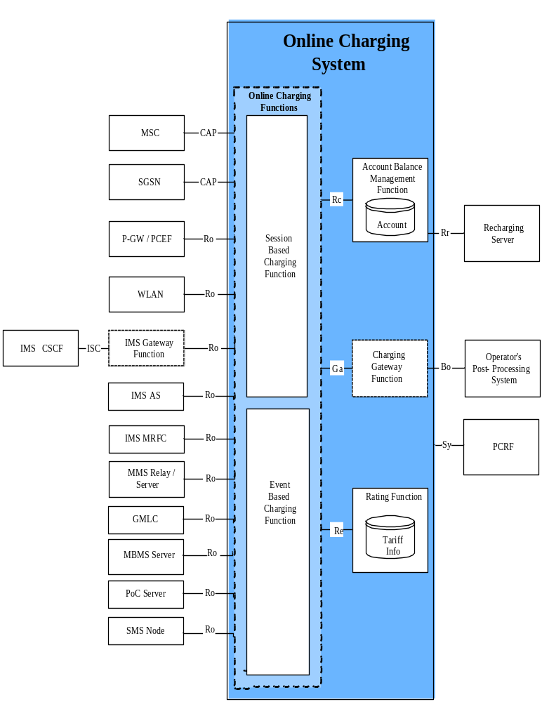
NOTE 1: The Rc, Re, Sy and Ga reference points connect both Online Charging Functions (i.e. the Session Based Charging Function and the Event Based Charging Function) with the Account Balance Management Function, the Rating Function, Policy and Charging Rules Function and the Charging Gateway Function.
NOTE 2: The support of ISC as charging interface towards IMS CSCF requires additional functionality to be provided by the OCS. The support of Ro as charging interface towards OCS requires additional functionality to be provided by the IMS CSCF.
NOTE 3: Only network entities covered in this Release are depicted. Other network entities may be connected to the OCS, but these are out of scope for the current release.

Figure 5.1: Online charging system architecture
Towards the SGSN, the OCS or a separate function could provide a translation between CAP and Ro. This is beyond the scope of the present document.
In case of Flow Based Charging (FBC), the PCEF is used for all PCC interactions between P-GW and OCS, for details refer to TS 32.251 [11].
For architectural details on the Ro reference point between WLAN and OCS, refer to TS 32.252 [12].
The architecture details on the Ro reference point used for IMS (IMS CSCF, IMS Application Server and IMS MRFC) specified in TS 32.260 [20].
The service specific architecture details on the Ro reference point are specified for the MMS Relay/Server in TS 32.270 [30], for the GMLC in TS 32.271 [31], for the PoC Server in TS 32.272 [32] for the MBMS Server in 3GPP TS 32.273 [33], for the SMS in TS 32.274 [34] and the MMTel in TS 32.275 [35].
The Session Based Charging Function (SBCF) performs session based charging on the bearer level using the CAP interface towards MSC and SGSN, and the Ro reference point towards other network elements. The Session Based Charging Function (SBCF) also performs session based charging on the subsystem level (i.e. IMS session charging) using the Ro reference point towards the IMS CSCF. Whether the CSCF is directly connected to the OCS or via a gateway (IMS Gateway Function) is beyond the scope of the present document.
The Event Based Charging Function (EBCF) performs event-based charging using the CAP interface towards MSC and SGSN (e.g. for charging of SMS), and the Ro reference point towards other network elements.
The Rating Function and the Account Balance Management Function are described in clause 4. The Re reference point allows the interaction between the Online Charging Functions (SBCF, EBCF) and the Rating Function.
The Rc reference point allows the interaction between the Online Charging Functions (SBCF, EBCF) and the Account Balance Management Function to access the subscribers account balance.
The Ga reference point allows the collection and transfer of charging information from the Charging Data Functions (CDF) to the Charging Gateway Function (CGF). In the context of online charging, the CDFs are always integrated into the Online Charging Functions (SBCF, EBCF). Whether the CGF is also integrated into the Online Charging Functions, or whether it is a separate function inside the OCS, or whether it is an external function outside the OCS is not defined in this 3GPP release.
The Bo reference point allows the transfer of charging information from the Charging Gateway Function to the operator's post-processing system as the OCS variant of the Bx interface description in TS 32.297 [52].
The Rr reference point allows the interaction between the Account Balance Management Function and an external recharging server.
The policy and charging control architecture is specified in TS 23.203 [206] and the Sy protocol details are specified in TS 29.213 [208] and TS 29.219 [207]. The Sy reference point allows the interaction between the OCS and Policy and Charging Rules Function (PCRF) for obtaining information from the OCS for policy decision purposes.
There may be other external systems connected to the OCS (e.g. hot billing server). These systems are not considered in the present document.

5.2 Functions within the OCS

5.2.1 Online Charging Functions

5.2.1.1 Event Based Charging Function
The Event Based Charging Function (EBCF) performs event based charging and credit control (e.g. content charging):
- on the bearer level, based on bearer usage requests received from the network. It controls the bearer usage in the network, e.g. SMS;
- on a subsystem level, based on session resource usage requests received from the network (e.g. the IMS MRFC). It controls the resource availability in network, e.g. it has the ability to grant or deny the resource usage;
- on service level, based on application server requests received from the network (e.g. an IMS application server or MMS relay server). It controls the application service availability in the network, e.g. it has the ability to grant or deny the service usage in the network.
It communicates with the Rating Function in order to determine the value of the requested service usage. It communicates with the Account Balance Management Function to query and update the subscribers' account and counters status (counters are not applicable if a class "B" Rating Function is used).
When a correlation process is enabled a correlation context may be consulted or created. If multiple chargeable events exist in the correlation context a combined request will be issued for the Rating Function.

5.2.1.2 Session Based Charging Function
The Session Based Charging Function (SBCF) performs session based charging and credit control:
- on the bearer level, based on bearer usage requests received from the network. It controls the bearer usage in the network, e.g. in terms of time or volume granted;
- on the subsystem level, based on session resource usage requests received from the network (e.g. the IMS CSCF). It controls sessions in the network, e.g. it has the ability to grant or deny a session setup request and to terminate an existing session;
- on the service level, based on service usage requests received from the network. It controls service availability in the network, e.g. it has the ability to grant or deny a usage of a service.
It communicates with the Rating Function in order to determine the value of the requested bearer resources or the requested session. It communicates with the Account Balance Management Function to query and update the subscribers' account and counters status (counters are not applicable if a class "B" Rating Function is used).
When a correlation process is enabled a correlation context may be consulted or created. If multiple chargeable events exist in the correlation context a combined request will be issued for the Rating Function.

5.2.2 Rating Function
The Rating Function performs both monetary and non-monetary unit determination (rating). It provides the following functionalities:
- Rating for network- and external services and applications (session, service, event) before and after service delivery;
- Cross-product and cross-channel discounts, benefits and allowances.
The Rating Function must be able to handle a wide variety of rateable instances, such as:
- Rating of volume (in terms of granted units or money, e.g. based on charging initiated by an access network entity);
- Rating of time (in terms of granted units or money, e.g. based on charging initiated by a SIP application);
- Rating of events (e.g. based on charging of web content or MMS).
The Rating Function includes the determination of the tariff or the price of a chargeable event or of multiple chargeable events (correlation scenario); examples include the price of a call minute, data volume, multimedia session, Web content, etc.
Upon receipt of a rate request (price or tariff request) from the Charging Function, the Rating Function:
- Evaluates the request. Rate requests include various rating parameters such as service identifier, subscriber reference, network identification, user location, service usage time, transferred data volume, etc. Note that the rate request may contain multiple service identifiers that reflect the list of active services contained in the context handled by the Charging Function.
- Determines the applicable price or tariff model and returns it to the Charging Function. Note that in case of multiple service requests received, the Rating Function may apply a special price or tariff which can be different to the price or tariff applied to the related services handled separately. For example when sending an MMS, the rating of volume associated with the bearer usage can be free of charge while the rating of the event and/or volume associated with the service level MMS submission is greater than zero. This correlation procedure depends on the operator configurable rating rules.
To support the online rating process, the Rating Function needs counters. The counters may be maintained by the Rating Function or by the Account Balance Management function. A Rating Function that does not maintain counters will be marked as class "A" Rating Function. A Rating Function that maintains counters will be marked as class "B" Rating Function.
Editor's Note: The handling of combined session and event requests is for further study.

6 Functionalities and Message Flows

6.1 Reference Point Required Functionality

6.1.1 Re Reference Point (EBCF, SBCF - Rating Function)

6.1.1.1 Functionality for class "A" Rating Function
The following applies with respect to the Rating Interface:
- The Rating Function will potentially cover all rating scenarios for all charging levels (bearer, session and service) and all payment channels (prepaid and postpaid).
- The Rating Function will cover the methods PriceRequest and TariffRequest.
- The Rating Function will operate in a stateless way on a per request basis. No context or state is stored internally.
- The Rating Function will not modify accounts or bonus counters directly. Instead it passes the corresponding information (instruction how to modify counters) as part of the response. Details are explained in the next subsection.
- The Rating Interface is an interface in a trusted environment. Session handling, transaction control or authentication / authorization are not required.
- No records are written by the Rating Function. Thus billing relevant information is part of the response.
Resulting from these requirements following functionality of Re reference point is proposed:
- Basic methods:
- Price Request (to calculate a price for given service usage);
- Tariff Request (to request a tariff that is applicable).
- Additional supported functionalities:
- Discounts by use of consumer specific counters;
- Loyalty programs;
- Taxes;
- Detailed information for use during invoice generation.
Depending on the service or product offered and on the customer's contract, the Rating Function supports the following methods:
- PriceRequest: Determination of a price for the execution of a service or the delivery of a good. From the rating perspective this is the same method if run before delivery (e.g. for balance check or AoC), after delivery (post-rating for charging) or even later in a rerating process. The same method applies for one-time or recurrent charges. The PriceRequest is used by the EBCF.
- TariffRequest: Determination of a tariff for a given service. This method is used, e.g., for voice calls, where tariff is returned by the Rating Function. Based on the tariff the charging function calculates either the amount of units for a given price or the price for a given number of units. The method can also be used for various other services. The TariffRequest is used by the SBCF.
Input for Rating:
- Rating Request Type: Price Request, Tariff Request.
- Service-specific data: Service-ID, Time/Date of Service usage, QoS, etc.
- Subscriber-specific static data: Subscriber-ID, Partner-ID (e.g. MVNO, merchant), additional tariff information (e.g. "Friends & Family" list), other static data.
- Subscriber specific dynamic data: Account Balances incl. units/currency (money, loyalty), Subscriber Counters (e.g. Service-Type (SMS/MMS/Volume/Time) used per time-unit (day/week/month/year), other dynamic data).
Output of Rating:
- Rating Request Type Response: Price or Service units or Tariff incl. tariff switch information
(Tariff Switch Time (absolute time/duration), etc.);
- Charge and Recharge Information: Value for accounts and Subscriber Counters (e.g. charge money, recharge loyalty accounts);
- Tax information;
- Detailed information to be used for invoice generation.

6.1.1.1.1 Class "A" Counter Handling
As defined in subsection 5.2.2, if a class "A" Rating Function is used, counters reside in the Account Balance Management Function. The Charging Functions fetch the counters from the Account Balance Management Function over the Rc Reference Point at the beginning of an online charging session, together with the account balance. The counter values are passed on to the Rating Function in the PriceRequest or TariffRequest method over the Re Reference Point. On the Re Reference Point, counters have to be supported in a very generic way in order to support the use of counters in the largest possible variety of call scenarios. The structure of counter elements on the Re interface is defined in section 7 of this document.
In the Rating Request, the Charging Function will inform the Rating Function about the current value and the expiry date of all applicable counters.
In the Rating Response, the Rating Function may instruct the Charging Function to modify counters. The following kinds of counter manipulation are supported:
- increase or decrease one or more specified counters with a specified value, once for this online charging session;
- increase or decrease one or more specified counters with a specified value per consumed service unit;
- increase or decrease one or more specified counters with a specified value per charged; the specified value and the tariff may change due to a tariff switch;
- set one or more specified counters explicitly to a specified value; this instruction can be used to reset counters;
if the specified counter does not exist, the Charging Function shall create this counter in the Account Balance Management Function; hence, using this instruction, the Rating Function can trigger the creation of new counters;
- set a counter threshold for one or more specified counters; when a threshold is reached, the tariff information from the Rating Response message expires, and the Charging Function shall send a new Rating Request message towards the Rating Function;
- set the expiry date of one or more specified counters.
Additionally, the Rating Function may give the following information to the Charging Function:
- a list of counters, which are applicable to the present online charging session; the Charging Function shall include only these counters in subsequent rating requests within this session; the list of applicable counters can be modified by the Rating Function in each Rating Response; the purpose of this information is to reduce load on the Re-interface.
Note that from a principal point of view, in class "A" the account balance can be considered as a special kind of counter: It resides in the Account Balance Management Function, it has a current value and an expiry date, and it will be modified during an online charging session by the Charging Function according to resource usage and according to information received from the Rating Function.

6.1.1.2 Functionality for class "B" Rating Function
If class "B" Rating Function is chosen, i.e. counters are maintained in the Rating Function, then the Re Reference Point is modified with respect to the previous clause in the following way:
- the Rating Function has to become statefull;
- the Rating Function has to modify counters directly;
- the Rating Function has to handle sessions / has to support transaction control;
- the PriceRequest and TariffRequest have to support reservations;
- TariffRequest: Determination of a tariff and price for a given session oriented service. This method is used, e.g., for voice calls, where tariff is returned by the Rating Function. At the beginning or during the session, the Rating Function receives requested service units and returns the tariff information. The charging function can grant the requested units or recalculate the granted units based on the returned tariff and the account balance. At the end of the session, the Rating Function returns the conclusive price of the consumed service. The method can also be used for various other services. The TariffRequest is used by the SBCF.
Scenarios involving granted units may be covered via a TariffRequest or by the Class "B" Rating Function directly. The handling of the first case is part of the charging function. For the latter case the Re interface offers a special request type:
- ServiceUsageRequest: This type of request, also called backward rating, determines the amount of units of a given service given the price. The ServiceUsageRequest is useful (but not limited) in the case where the subscriber's price plan is formed in usage per monetary units amount (e.g. 45 seconds per 100 Yen). Since the basic requirements are covered by the former requests, this request is optional.

6.1.2 Rc Reference Point (EBCF, SBCF - Account Balance Management Function)
Details of functionality across the Rc reference point and interface Implementation options are provided in Annex B.

6.2 Re Message Flows
This subclause describes message flows for the Re Reference Point by explaining example online charging sessions (i.e. credit control sessions on the Ro interface or CAP dialogues).
On the interface towards the serving network nodes (i.e. Ro, CAP) the generic message names "online charging request" and "online charging response" are used. These generic names should be mapped to real messages depending on the type of interface as indicated in the following table.
generic name | Ro Interface | CAP Interface
online charging request | Credit Control Request (CCR) | first message, initiating the charging dialogue:  - Initial DP,  - Initial DP GPRS,  - Initial DP SMS  subsequent messages:  - Apply Charging Report, Event Report BCSM,  - Apply Charging Report GPRS, Event Report GPRS,  - Event Report SMS
online charging response | Credit Control Answer (CCA) | - Apply Charging, Request Report BCSM Event (+ Connect / Continue),  - Apply Charging GPRS, Request Report GPRS Event (+ Connect GPRS /  Continue GPRS),  - Request Report SMS Event, Connect SMS, Continue SMS

For details on the CAP messages and message flows, refer to 3GPP TS 23.078 [202].
It should be noted that several service requests can be included in one message using Services-Rating AVP. The basic functionality of the single or multiple requests are the same so only single request scenario is described in message flows.
In addition to the differences between a class "A" and a class "B" Rating Function as described in the previous subclause, the Re message flows of both classes differ from a principal point of view as follows:
- In class "A", a TariffRequest is sent by the ChargingFunction only when an online charging request is received from the network, and no valid tariff is known (i.e. at the beginning of an online charging session or after tariff expiry). Therefore, distinction between different scenarios in the following description is necessary.
- In class "B", a TariffRequest is sent by the ChargingFunction after every online charging request received from the network. Therefore, no distinction between different TariffRequest scenarios is necessary.

6.2.1 Class "A" Rating Function Message Flows

6.2.1.1 PriceRequest method
The PriceRequest method is used only for event based charging, i.e. only the EBCF uses this method.
According to 3GPP TS 32.299 [50], two different scenarios need to be distinguished, the Immediate Event Charging (IEC) and the event charging with unit reservation (ECUR).
Both scenarios in this section describe the case where the EBCF invokes the PriceRequest method for charging or Advice of Charge.

6.2.1.1.1 PriceRequest scenario with Immediate Charging
The following figure describes the case where the EBCF invokes the PriceRequest method in an Immediate Event Charging (IEC) scenario.
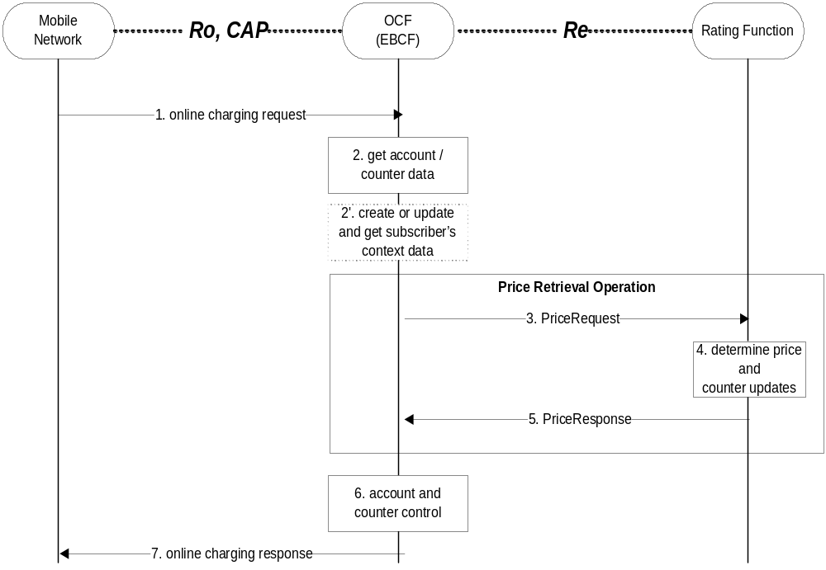
Figure : Price Request Method with immediate charging
Step 1: The EBCF receives an online charging request for a certain event/service.
Step 2: The EBCF requests account and counter information for the subscriber from the Account Balance Management Function.
Step 2' (Optional):In case there is no existing subscriber's context, the EBCF creates a new subscriber's context information. Otherwise, the EBCF updates the existing subscriber's context and gets the list of active services for the given subscriber (see note below). This Step only applies when correlation is enabled.
Step 3: Upon receipt of this data, the EBCF sends a price request to the Rating Function in order to determine the price of the desired service. Note that this scenario assumes that the EBCF has not received any service cost information in the online charging request. Note that the Price Request may contain several service requests depending on the number of ongoing services.
Step 4: The Rating Function calculates the price and counter updates for the given service according to the service and subscriber specific information included in the request.
Step 5: The calculated price and counter updates are returned to the EBCF.
Step 6: The EBCF continues event charging and performs account and counter control (i.e. it checks and adjusts the account and counter values).
Step 7: The EBCF sends the appropriate online charging response.
If the Price Request Method with immediate charging is used, the service delivery may occur before or after the online charging dialogue.
In addition to the price, the PriceResponse may also include "Basic Price". This may be used e.g. to realize a basic fee, that is applicable once per day/week/month, if a certain service is used. Note that the Basic Price may be service specific. The EBCF has to include the timestamp of the last charging of the Basic Price in the PriceRequest, if the Basic Price is applicable. This handling applies also for the PriceRequest scenario with Unit Reservation as described in the following subsection.
NOTE: If a context already exists when the EBCF interrogates the context, then the EBCF may optionally get the price for the desired service.

6.2.1.1.2 PriceRequest scenario with Unit Reservation
The following figure describes the case where the EBCF invokes the PriceRequest method in an event charging with unit reservation (ECUR) scenario.

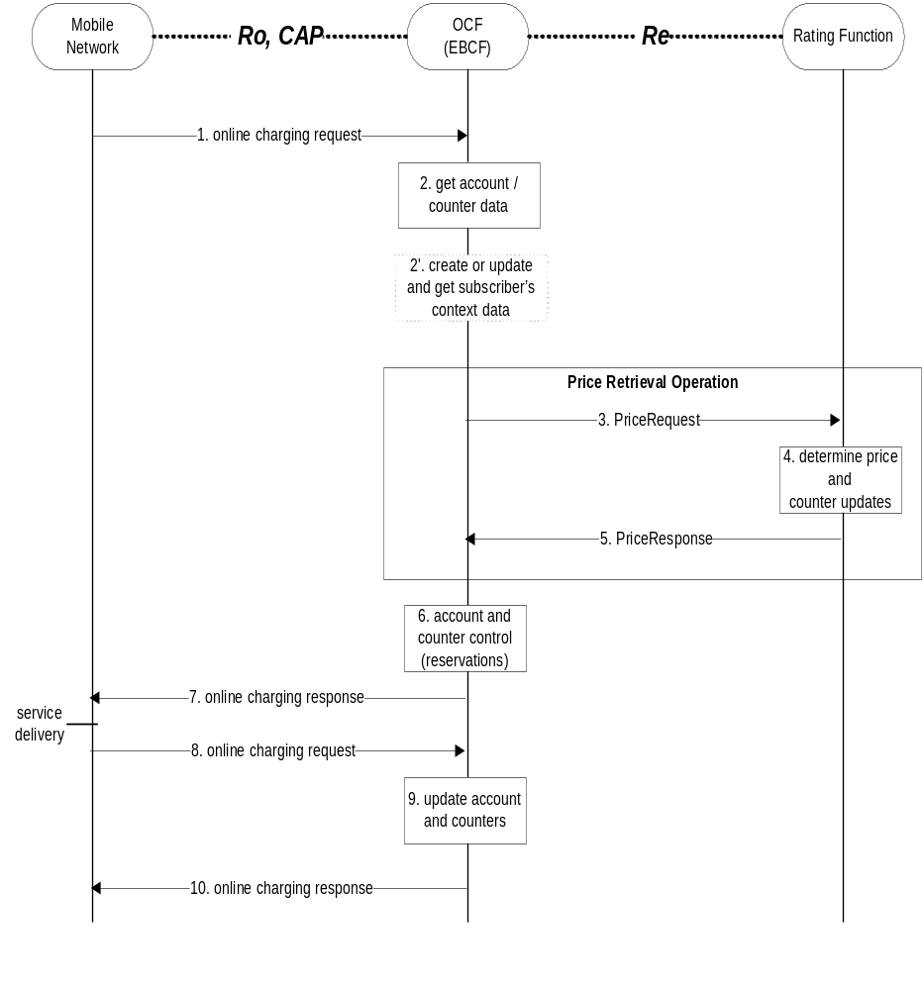
Figure : Price Request Method with unit reservation
Step 1: The EBCF receives an online charging request for a certain event/service.
Step 2: The EBCF requests account and counter information for the subscriber from the Account Balance Management Function.
Step 2' (Optional):In case there is no existing subscriber's context, the EBCF creates a new subscriber's context information. Otherwise, the EBCF updates the existing subscriber's context and gets the list of active services for the given subscriber. This Step only applies when correlation is enabled.
Step 3: Upon receipt of this data, the EBCF sends a price request to the Rating Function in order to determine the price of the desired service. Note that this scenario assumes that the EBCF has not received any service cost information in the online charging request.
Step 4: The Rating Function calculates the price and counter updates for the given service according to the service and subscriber specific information included in the request.
Step 5: The calculated price and counter updates are returned to the EBCF.
Step 6: The EBCF continues event charging and performs account and counter control (i.e. it makes reservations for the requested service).
Step 7: The EBCF sends the appropriate online charging response (i.e. it grants or denies service delivery).
Step 8: After service delivery, the serving network node sends an indication of successful (or unsuccessful) service delivery to the EBCF.
Step 9: The EBCF performs account and counter control (i.e. it adjusts the account and counter values accordingly).
Step 10: Finally, the EBCF sends an acknowledgment message to the serving network node in order to terminate the online charging dialogue.
If the second online charging request (step 8) contains updated information about the consumed service, a second Price Retrieval Operation may occur between step 8 and step 9, i.e. the EBCF may send a second PriceRequest containing the updated information to the Rating Function. The Rating Function will send an appropriate PriceResponse, and the information contained in this second PriceResponse may be used by the EBCF for account and counter control (step 9).
If the second online charging request (step 8) contains information about the release of the ongoing service, the EBCF updates the existing subscriber's context to remove the entry related to this service and to get the list of remaining active services. A second Price Retrieval Operation may occur between step 8 and step 9, i.e. the EBCF may send a second PriceRequest containing the updated information to the Rating Function. The Rating Function will send an appropriate PriceResponse containing the updated price for the remaining ongoing services and the information contained in this second PriceResponse may be used by the EBCF for account and counter control (step 9).

6.2.1.2 TariffRequest method
The TariffRequest method is used for bearer charging and IMS session charging, i.e. only the SBCF uses this method.
All scenarios in this section describe the case where the SBCF invokes the tariffRequest method for charging or Advice of Charge. All scenarios are valid independent of the type of applicable "units" (i.e. for both, time or volume).
In the context of bearer charging or session charging, only the event charging with unit reservation (ECUR) (3GPP 32.299 [50]) is relevant. Therefore, only ECUR is considered in this section.

6.2.1.2.1 Basic TariffRequest scenario
The following figure shows a basic message flow for the tariff request method.
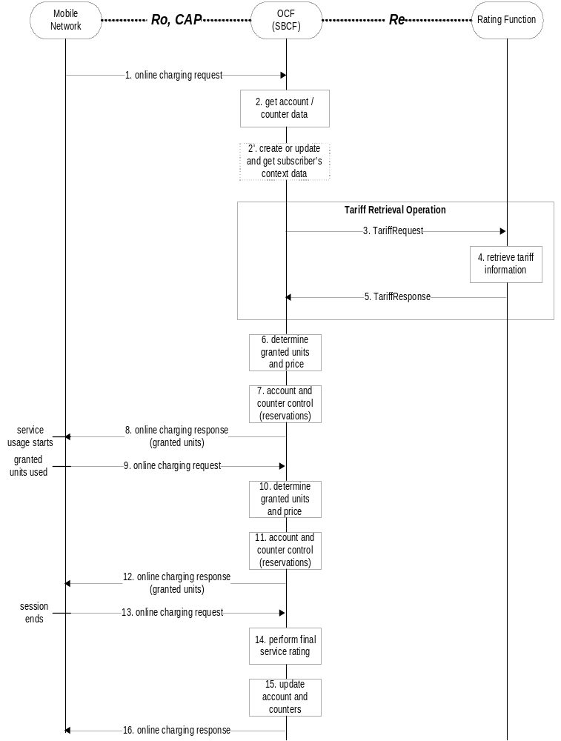

Figure : Basic Tariff request method
Step 1: The SBCF receives an online charging request referring to an MS's bearer/session resource usage.
Step 2: The SBCF requests account and counter information for the subscriber from the Account Balance Management Function.
Step 2' (Optional):In case there is no existing subscriber's context, the SBCF creates a new subscriber's context information. Otherwise, the SBCF updates the existing subscriber's context and gets the list of active services for the given subscriber. This Step only applies when correlation is enabled.
Step 3: Upon receipt of this data, the SBCF requests tariff information applicable for this bearer/session.
Step 4: The Rating Function retrieves the appropriate tariff to be applied for the bearer/session.
Step 5: The Rating Function returns the tariff information to the SBCF.
Step 6: Based on the received tariff information, the SBCF determines the granted units and the price.
Step 7: The SBCF continues bearer/session charging and performs account and counters control (i.e. it makes reservations).
Step 8: Assuming successful account control, the SBCF returns the granted units to the requesting network element. Service usage can start immediately or later.
Step 9: When the granted units have been used, a new request is send from the serving network element to the SBCF.
Step 10: This time the SBCF can directly determine the granted units and the price.
Step 11: The SBCF performs account and counter control (i.e. it makes reservations).
Step 12: Again, assuming successful account control, a positive acknowledgment (including granted units) is returned to the network entity.
Step 13: The MS terminates bearer/session usage. The used units are sent to the SBCF.
Step 14: The SBCF performs final rating for the consumed bearer/session resources.
Step 15: The SBCF adjusts the account and counters accordingly.
Step 16: Finally, the SBCF sends an acknowledgment message to the serving network node in order to terminate the online charging dialogue.
In this basic scenario only one request to the Rating Function is needed during the whole online charging session.
The message flow in the previous figure is an example of an online charging session to illustrate the usage of the basic Tariff Request method on the Re interface. The sequence of steps 9-12 is optional or can be repeated multiple times.
If the SBCF detects that the account balance is not sufficient for a minimum number of granted units (in step 6 in the example), there will be no reservation (step 7 will be skipped), and the SBCF will deny the online charging request (in step 8), i.e. the service usage request will be rejected by the mobile network. The same handling applies if the account reservation fails (in step 7, 11). Note that this can only occur, if the account is modified independently of the current online charging session, e.g. due to several parallel online charging sessions. This handling of insufficient account balances applies for all class "A" TariffRequest scenarios, i.e. also for the following subsections.
This basic scenario assumes, that the tariff information is valid for the whole online charging session (i.e. the tariff is not affected by the amount of resources used, the time of day, etc.).
In addition to the tariff information, the TariffResponse may also include "Basic Price", that is deducted directly from the subscriber's account balance. This may be used e.g. to realize a basic fee, that is applicable once per day/week/month, if a certain service is used. Note that the Basic Price may be service specific. The SBCF has to include the timestamp of the last charging of the Basic Price in the TariffRequest, if the Basic Price is applicable. This handling applies for all class "A" TariffRequest scenarios, i.e. also for the following subsections.

6.2.1.2.2 TariffRequest Scenario with multiple Tariff Switches and Expiry Time
The following figure shows a message flow for the tariff request method with multiple tariff switches, i.e. the tariff will change at specified times, multiple times during the online charging session.
To allow for correct charging of this kind of scenarios, the rating function needs to make sure that all tariff information contained in a TariffResponse message expires between the next two tariff switches, i.e. between the tariff switch time that is defined within this TariffResponse message and the next subsequent tariff switch time. For this purpose, a parameter ExpiryTime is used. The ExpiryTime defines, how long the tariff information contained in the TariffResponse message is valid after the timestamp of the TariffRequest that triggered this response. For the handling of multiple tariff switches, it is recommended to set the ExpiryTime to the difference between the next two tariff switch times.
It should be noted that the ExpiryTime may also be used when no tariff switch is foreseen, to ensure a subsequent tariff retrieval operation after a specified time period has passed.
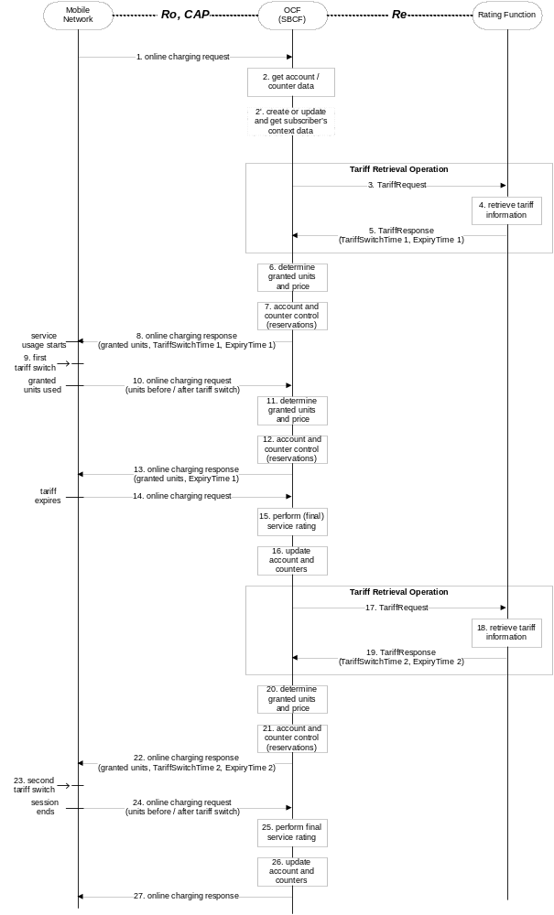

Figure : Tariff request method with multiple tariff switches
Step 1: The SBCF receives an online charging request referring to an MS's bearer usage/session resource usage.
Step 2: The SBCF requests account and counter information for the subscriber from the Account Balance Management Function.
Step 2' (Optional):In case there is no existing subscriber's context, the SBCF creates a new subscriber's context information. Otherwise, the SBCF updates the existing subscriber's context and gets the list of active services for the given subscriber. This Step only applies when correlation is enabled.
Step 3: Upon receipt of this data, the SBCF requests tariff information applicable for this bearer/session.
Step 4: The Rating Function retrieves the appropriate tariff to be applied for the bearer/session.
Step 5: The Rating Function returns the tariff information to the SBCF, including indication of an upcoming tariff switch and the appropriate expiry time.
Step 6: Based on the received tariff information, the SBCF determines the granted units and the price.
Step 7: The SBCF continues bearer/session charging and performs account and counter control (i.e. it makes reservations).
Step 8: It returns the granted units, an indication of the upcoming tariff switch, and the expiry time to the requesting network element. Service usage can start immediately or later.
If supported by the online charging response message, the SBCF may return two quota of granted units, one valid before the tariff switch, the other valid after the tariff switch.
Step 9: The (first) tariff switch occurs in the network.
Step 10: When the granted units have been used, a new request is send from the serving network element to the SBCF. The units used before and after the tariff switch are sent to the SBCF as separate values in this request.
Step 11: Since the tariff information from the last TariffResponse (step 5) has not expired, the SBCF can directly determine the next granted units and the price.
Step 12: The SBCF continues bearer/session charging and performs account and counter control (i.e. it makes reservations).
Step 13: Again, assuming successful account control, a positive acknowledgment (including granted units and an indication of the expiry time) is returned to the requesting network element.
Step 14: When the tariff expires (i.e. the expiry time is reached), a new request is send from the serving network element to the SBCF immediately. This request includes the number of units consumed so far.
Step 15: The SBCF performs (final) rating for the bearer/session resources consumed so far.
Step 16: The SBCF adjusts the account and counters accordingly.
Step 17: The SBCF again requests tariff information applicable for the bearer/session.
Step 18: The Rating Function retrieves the appropriate tariff to be applied for the bearer/session.
Step 19: The Rating Function returns the tariff information to the SBCF, including indication of the next upcoming tariff switch and the appropriate expiry time.
Step 20: Based on the received tariff information, the SBCF determines the granted units and the price.
Step 21: The SBCF continues bearer/session charging and performs account and counter control (i.e. it makes reservations).
Step 22: It returns the granted units, an indication of the next upcoming tariff switch, and the expiry time to the requesting network element.
Step 23: The (second) tariff switch occurs in the network.
Step 24: The MS terminates bearer/session usage. The units used before and after the (second) tariff switch are sent to the SBCF as separate values.
Step 25: The SBCF performs final rating for the consumed bearer/session resources.
Step 26: The SBCF adjusts the account and counters accordingly.
Step 27: Finally, the SBCF sends an acknowledgment message to the serving network node in order to terminate the online charging dialogue.
In this scenario one request to the Rating Function is needed for every tariff switch. No messages are sent at the time when a tariff switch occurs. The SBCF is informed about the units used before and after the tariff switch in the first online charging request, that is sent after the tariff switch has occurred (steps 10 and 24 in the example scenario). The handling when the tariff expires due to the parameter ExpiryTime is similar to the closing of one online charging session and the immediate starting of a new online charging session.
The message flow in the previous figure is an example of an online charging session to illustrate the usage of the Tariff Request method on the Re interface if handling of multiple tariff switches is required. Variations of this message flow will occur, depending on the exact times when the tariff switches occur, on the number of tariff switches during the online charging session, etc. Of course, it is also possible that the granted units are used in the network or that the session ends without the occurrence of a tariff switch.
If only one tariff switch is foreseen, the ExpiryTime parameter is not needed. In this case, the message flow will be identical to the basic scenario as described in subclause 6.2.1.2.1. A single tariff switch does not lead to any additional messages, nor does it require any additional handling in the SBCF.

6.2.1.2.3 TariffRequest Scenario with limited validity
The following figure shows a message flow for the tariff request method with limited validity, i.e. the tariff is only valid for a limited number of used service units (e.g. seconds, Kbytes) or until a counter threshold is reached. This scenario applies e.g. for regressive tariffs or for the usage of free / discounted service units.
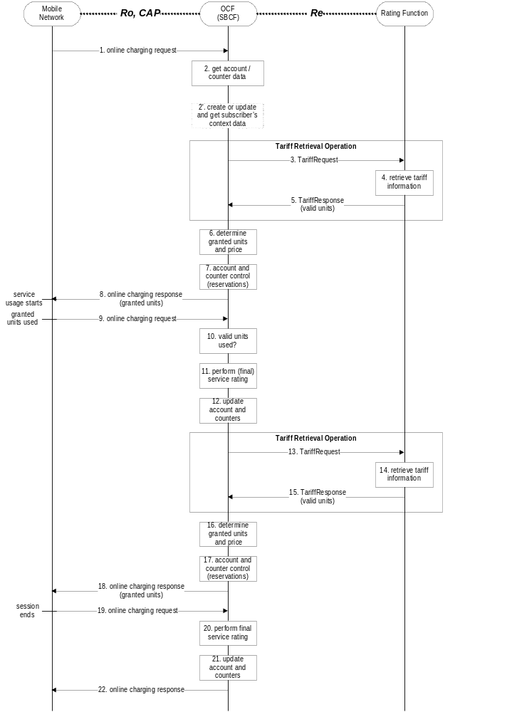
Figure : Tariff request method with valid units
Step 1: The SBCF receives an online charging request referring to an MS's bearer usage/session resource usage.
Step 2: The SBCF requests account and counter information for the subscriber from the Account Balance Management Function.
Step 2' (Optional):In case there is no existing subscriber's context, the SBCF creates a new subscriber's context information. Otherwise, the SBCF updates the existing subscriber's context and gets the list of active services for the given subscriber. This Step only applies when correlation is enabled.Step 3: Upon receipt of this data, the SBCF requests tariff information applicable for this bearer/session.
Step 4: The Rating Function retrieves the appropriate tariff to be applied for the bearer/session.
Step 5: The Rating Function returns the tariff information to the SBCF, including indication of the number of units for which this tariff is valid.
Step 6: Based on the received tariff information, the SBCF determines the granted units and the price.
Step 7: The SBCF continues bearer/session charging and performs account and counter control (i.e. it makes reservations).
Step 8: It returns the granted units to the requesting network element. Service usage can start immediately or later. Note that the number of granted units is in general different from the number of "valid units" received from the Rating Function (i.e. the number of granted units can be smaller than the number of valid units).
Step 9: When the granted units have been used, a new request is send from the serving network element to the SBCF.
Step 10: The SBCF checks, whether all valid units have been used. If there are valid units left, the scenario continues with step 6 again.
Step 11: If all valid units have been used, the SBCF performs (final) rating for the bearer/session resources consumed so far.
Step 12: The SBCF adjusts the account and counters accordingly.
Step 13: The SBCF again requests tariff information applicable for the bearer/session.
Step 14: The Rating Function retrieves the appropriate tariff to be applied for the bearer/session.
Step 15: The Rating Function returns the tariff information to the SBCF, including indication of the number of units for which this tariff is valid.
Step 16: Based on the received tariff information, the SBCF determines the granted units and the price.
Step 17: The SBCF continues bearer/session charging and performs account and counter control (i.e. it makes reservations).
Step 18: It returns the granted units to the requesting network element.
Step 19: The MS terminates bearer/session usage. The used units are sent to the SBCF.
Step 20: The SBCF performs final rating for the consumed bearer/session resources.
Step 21: The SBCF adjusts the account and counters accordingly.
Step 22: Finally, the SBCF sends an acknowledgment message to the serving network node in order to terminate the online charging dialogue.
In this scenario two requests to the Rating Function are needed during the online charging session. In general, one additional request is needed, whenever a tariff expires (i.e. whenever the number of valid units has been consumed or whenever a counter threshold is reached). The handling when the number of valid units has been consumed is similar to the closing of one online charging session and the immediate starting of a new online charging session.
The message flow in the previous figure is an example of an online charging session to illustrate the usage of the Tariff Request method on the Re interface, if the tariff is valid only for a limited number of service units. The sequence of steps 6-10 can be repeated multiple times (as already indicated in step 6), and also the sequence of steps 6-15 can be repeated multiple times (i.e. including the complete consumption of valid units and a new request towards the Rating Function).
An optional optimization of the message flow with respect to service availability is as follows: If the Charging Function is informed about the tariff that is valid after all valid units have been used, the SBCF can send an online charging response and grant the usage of a limited amount of units based on the new tariff immediately after all valid units have been used (i.e. after step 10); in parallel, the SBCF requests new tariff information from the Rating Function as described above (steps 11 - 15); when the granted units have been used, the mobile network will send an online charging request to the SBCF, and processing continues in step 16 as described above.
A TariffRequest scenario with limited validity, where the tariff is only valid for a limited number of used service units, may also be combined with a tariff switch scenario (ref. subclause 6.2.1.2.2). Operators should take care, that proper interworking is ensured. In general it is recommended, that the first condition that leads to tariff expiry (i.e. expiry time or consumption of all valid units) shall lead to an account and counters update and trigger a new TariffRequest towards the RatingFunction if interworking between these scenarios needs to be ensured.

6.2.1.2.4 TariffRequest Scenario with unsolicited changes of session parameters
The following figure shows a message flow for the tariff request method in a scenario, where the tariff depends on the Quality of Service (QoS). In this case, a new tariff applies whenever the QualityOfService in the network changes. The QoS change is an example of an unsolicited change of charging relevant session parameters in the network.
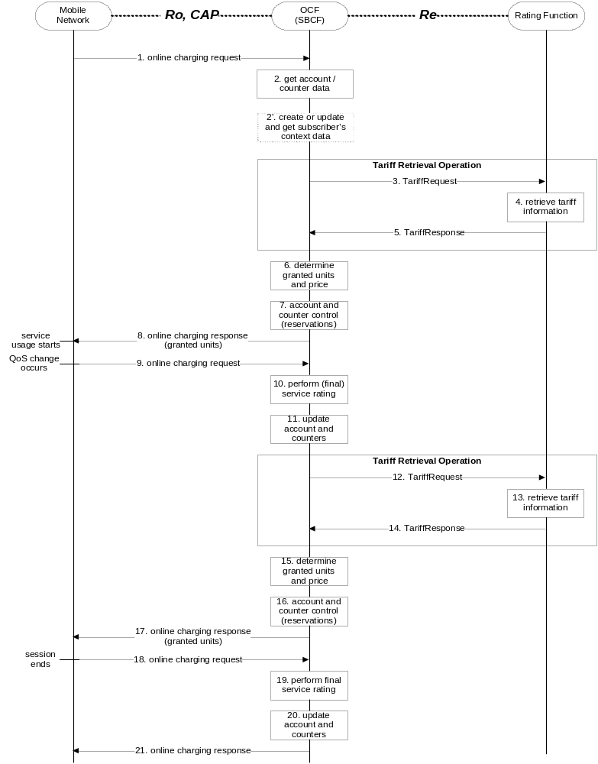
Figure : Tariff request method with charging based on QoS
Step 1: The SBCF receives an online charging request referring to an MS's bearer usage/session resource usage.
Step 2: The SBCF requests account and counter information for the subscriber from the Account Balance Management Function.
Step 2' (Optional):In case there is no existing subscriber's context, the SBCF creates a new subscriber's context information. Otherwise, the SBCF updates the existing subscriber's context and gets the list of active services for the given subscriber. This Step only applies when correlation is enabled.Step 3: Upon receipt of this data, the SBCF requests tariff information applicable for this bearer/session.
Step 4: The Rating Function retrieves the appropriate tariff to be applied for the bearer/session.
Step 5: The Rating Function returns the tariff information to the SBCF.
Step 6: Based on the received tariff information, the SBCF determines the granted units and the price.
Step 7: The SBCF continues bearer/session charging and performs account and counter control (i.e. it makes reservations).
Step 8: It returns the granted units to the requesting network element. Service usage can start immediately or later.
Step 9: When a QoS change occurs in the network, a new request is send from the serving network element to the SBCF immediately. This request includes the number of units consumed so far.
Step 10: The SBCF performs (final) rating for the bearer/session resources consumed so far.
Step 11: The SBCF adjusts the account and counters accordingly.
Step 12: The SBCF again requests tariff information applicable for the bearer/session. Note that the new (changed) QoS is included in this request.
Step 13: The Rating Function retrieves the appropriate tariff to be applied for the bearer/session.
Step 14: The Rating Function returns the tariff information to the SBCF.
Step 15: Based on the received tariff information, the SBCF determines the granted units and the price.
Step 16: The SBCF continues bearer/session charging and performs account and counter control (i.e. it makes reservations).
Step 17: It returns the granted units to the requesting network element.
Step 18: The MS terminates bearer/session usage. The used units are sent to the SBCF.
Step 19: The SBCF performs final rating for the consumed bearer/session resources.
Step 20: The SBCF adjusts the account and counters accordingly.
Step 21: Finally, the SBCF sends an acknowledgment message to the serving network node in order to terminate the online charging dialogue.
In this scenario two requests to the Rating Function are needed during the online charging session. In general, one additional request is needed, whenever the QualityOfService changes in the network. A change in the QualityOfService is handled similar to the closing of one online charging session and the immediate starting of a new online charging session.
The message flow in the previous figure is an example of an online charging session to illustrate the usage of the Tariff Request method on the Re interface, if the tariff expires due to an unsolicited change of charging relevant session parameters in the mobile network. Besides a QualityOfService change, other events in the network that could cause a tariff expiry include e.g. a location change, an SGSN change, etc. Also, e.g. the sequence of steps 6-9 can be repeated multiple times (if no QoS change occurs and the granted units have been used in step 9), and also the sequence of steps 6-14 can be repeated multiple times (if multiple QoS changes occur).

6.2.2 Class "B" Rating Function Message Flows

6.2.2.1 PriceRequest method
The PriceRequest method is used only for event based charging, i.e. only the EBCF uses this method.
According to 3GPP TS 32.299 [50], two different scenarios need to be distinguished, the Immediate Event Charging (IEC) and the event charging with unit reservation (ECUR).

6.2.2.1.1 PriceRequest scenario with Immediate Charging
The following figure describes the case where the EBCF invokes the PriceRequest method in an Immediate Event Charging (IEC) scenario.
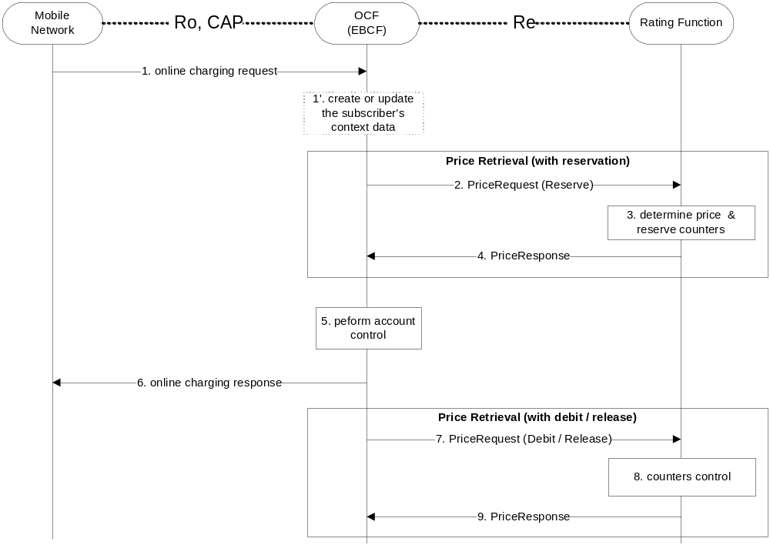
Figure : PriceRequest method with Immediate Charging
Step 1: The EBCF receives an online charging request for a certain event/service.
Step 1' (Optional):In case there is no existing subscriber's context, the EBCF creates a new subscriber's context information. Otherwise, the EBCF updates the existing subscriber's context and get the list of active services for the given subscriber. This Step only applies when correlation is enabled.
Step 2: The EBCF sends a price request with a reserve instruction to the Rating Function to determine the price of the desired service. Please note that this scenario assumes that the EBCF has not received any service cost information in the online charging request.
Step 3: The Rating Function calculates the price and reserves the counters related to the given service according to the service and subscriber specific information included in the request.
Step 4: The calculated price is returned to the EBCF.
Step 5: The EBCF continues event charging and performs account control (i.e. it checks and adjusts the account balance).
Step 6: The EBCF sends the appropriate online charging response (i.e. service granted or denied, based on the account control result).
Step 7: Assuming a successful account control, the EBCF sends a price request with a debit instruction to the Rating Function. Otherwise, the EBCF sends a price request with a release instruction.
Step 8: The Rating Function updates or releases counters as appropriate.
Step 9: The Rating Function acknowledges the operation to the EBCF.

Note that from the network perspective there is immediate charging as described in 3GPP TS 32.299 [50], i.e. there is no reservation on the account balance. Nevertheless, internal reservations in the OCS on the counters may be involved as shown here.

6.2.2.1.2 PriceRequest scenario with Unit Reservation
The following figure describes the case where the EBCF invokes the PriceRequest method to make reservation but debits after service delivery. Two PriceRequests are always issued (Reserve & Debit).
The service parameters may be changed in the second request.
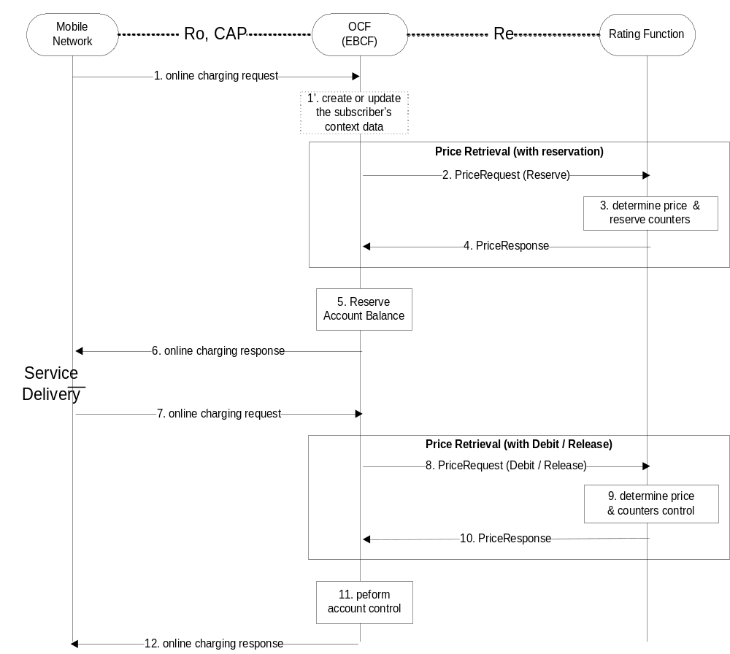

Figure : PriceRequest method with Unit Reservation
Step 1: The EBCF receives an online charging request for a certain event/service.
Step 1' (Optional):In case there is no existing subscriber's context, the EBCF creates a new subscriber's context information. Otherwise, the EBCF updates the existing subscriber's context and get the list of active services for the given subscriber. This Step only applies when correlation is enabled.
Step 2: The EBCF sends a price request with a reserve instruction to the Rating Function in order to determine the price of the desired service. Please note that this scenario assumes that the EBCF has not received any service cost information in the online charging request.
Step 3: The Rating Function calculates the price and reserves the counters related to the given service according to the service and subscriber specific information included in the request and
Step 4: the calculated price is returned to the EBCF.
Step 5: The EBCF reserves the calculated price from the subscriber's account.
Step 6: Upon successful reservation it grants the service usage or rejects the service if there is insufficient balance or if the reservation fails.
Step 7: After service delivery, the serving network node sends an indication of successful (or unsuccessful) service delivery to the EBCF. (This step is omitted if the service was rejected in the previous step.)
Step 8: Assuming a successful service delivery, the EBCF sends a price request with a debit instruction to the Rating Function. Please note that the request may contain updated information about the consumed service. If the service was rejected in step 6 or was not successfully delivered, the EBCF sends a price request with a release instruction instead.
Step 9: The Rating Function re-calculates the price if needed and updates or releases the counters as necessary.
Step 10: The final calculated price is returned to the EBCF if the service was delivered successfully. Otherwise a release acknowledgment is sent.
Step 11: The EBCF performs account control, if applicable.
Step 12: Finally, the EBCF sends an acknowledgment message to the serving network node in order to terminate the online charging dialogue, if the service was delivered successfully.

6.2.2.2 TariffRequest method
The TariffRequest method is used for bearer charging and IMS session charging, i.e. only the SBCF uses this method.
All scenarios in this section describe the case where the SBCF invokes the tariffRequest method for charging or Advice of Charge. All scenarios are valid independent of the type of applicable "units" (i.e. for both, time or volume).
In the context of bearer charging or session charging, only the Session charging with unit reservation (SCUR) (3GPP 32.299 [50]) is relevant. Therefore, only SCUR is considered in this section.

6.2.2.2.1 TariffRequest scenario with successful service delivery
The following figure describes the message flow for the tariff request method. The scenario describes the case where the SBCF invokes the tariffRequest method for charging several times during the same session, with successful reservation and service delivery.
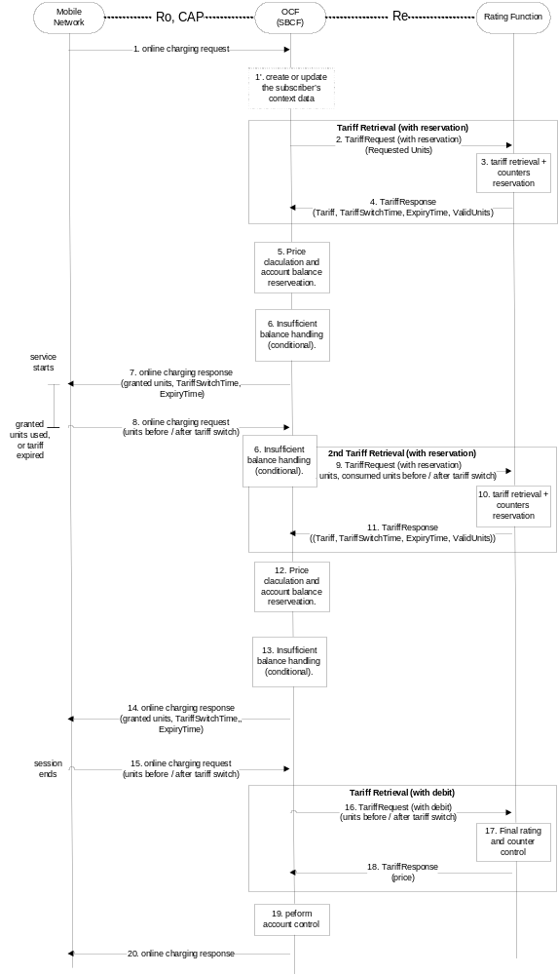
Figure : Tariff request scenario with successful service delivery
Step 1: The SBCF receives an online charging request referring to an MS's bearer/session usage.
Step 1' (Optional):In case there is no existing subscriber's context, the SBCF creates a new subscriber's context information. Otherwise, the SBCF updates the existing subscriber's context and get the list of active services for the given subscriber. This Step only applies when correlation is enabled.
Step 2: The SBCF requests tariff information applicable for this bearer/session. The initial amount of requested units is predetermined according to the operator policy. Note that the requested units are required for counters reservation in the Rating Function.
Step 3: The Rating Function retrieves the appropriate tariff to be applied for the bearer/session and reserves counter values if needed.
Step 4: The Rating Function returns the tariff information to the SBCF.
Step 5: Based on the received tariff, the SBCF calculates the price. The SBCF performs account balance reservation.
Step 6: If the reservation fails due to insufficient account balance, the SBCF recalculates the granted units and price based on the received tariff information and the available account balance. Note that the granted units are limited by the amount of requested units and the amount of valid units. The SBCF performs an adjusted account balance reservation.
Step 7: Assuming a successful account balance reservation, the SBCF returns the granted units to the requesting network element. Otherwise, the service is being denied (see subclause 6.2.2.2.2 for details).
Step 8: When the granted units have been used or the tariff has expired, a new request is send from the network element to the SBCF.
Step 9: The SBCF requests another quota of requested units for the service. The amount of requested units can be optimized, based on the tariff information and account balance.
Step 9-14: Repeat steps 2-7.
Step 15: The session ends and a final charging request is issued with updated session details (e.g. exact session length).
Step 16: The SBCF sends a final rating request with a debit instruction.
Step 17: The Rating Function performs final rating for the consumed resources and adjusts the counters accordingly.
Step 18: The Rating Function returns the final price to the SBCF.
Step 19: Based on the received price, the SBCF performs final account control.
Step 20: Finally, the SBCF sends an acknowledgment message to the serving network node in order to terminate the online charging dialogue.
In this scenario a tariff request message is send whenever an online charging request is received from the mobile network. The first tariff request message at the beginning of the session is marked "with reservation". The last tariff request at the end of the session is marked "with debit". Any number (0 or more) of tariff requests (marked "with reservation") can appear during the session. During the session steps 9-14 can be repeated multiple times. Between any repetitions of those sequences, the charging session parameters that are relevant for rating may change. The change can be solicited (e.g. tariff switch) or unsolicited (e.g. QoS change). The network element issues another charging request in those cases i.e. on expiry time if tariff switch occurred, when granted units are consumed or QoS is changed.
To allow for correct charging of this kind of scenarios, the rating function needs to make sure that all tariff information contained in a TariffResponse message expires between the next two tariff switches, i.e. between the tariff switch time that is defined within this TariffResponse message and the next subsequent tariff switch time. For this purpose, a parameter ExpiryTime is used. The ExpiryTime defines, how long the tariff information contained in the TariffResponse message is valid after the timestamp of the TariffRequest that triggered this response. For the handling of multiple tariff switches, it is recommended to set the ExpiryTime to the difference between the next two tariff switch times.
It should be noted that the ExpiryTime may also be used when no tariff switch is foreseen, to ensure a subsequent tariff retrieval operation after a specified time period has passed.
The tariff request message contains session, subscriber and service information, the number of the requested units (quota) from the service and information about the previously consumed service quota, as applicable.
In the first tariff request message, the number of the requested units is predetermined in the SBCF (e.g. according to the service; 15 Minutes for a data service as an example). The rating function retrieves the appropriate tariff, makes counters reservations and returns the tariff.
In subsequent tariff request messages, the charging function can take into account the account balance and the applied tariff and try to optimize the number of the requested units in order to minimize the number of tariff retrievals. The charging function sends information on both, the passed quota and the new quota. Specifically, when a tariff switch occurred, the charging function shall pass the consumed units before and after the tariff switch in the following tariff request message. The rating function, adjusts the reserved counters if needed as a result from the updated information. The rating function makes new counters reservations for the next quota and returns the tariff for the next quota.
In the response to the tariff request message with reservation indication the rating function returns the applicable tariff. The charging function is responsible to calculate the price and to keep the account balance reservation accordingly.
If the calculated price is higher than the account balance, the charging function shall re-calculate the price and the number of the granted service units based on the received tariff information and the account balance. The rating function will adjust the counter reservation based on the actual number of service units consumed in a subsequent Tariff Request message.
In response to a TariffRequest message with debit indication, the TariffResponse message contains the final service price.

6.2.2.2.2 TariffRequest scenario with service denial or unsuccessful delivery
The following figure describes the message flow for the tariff request method. The scenario describes the case where the SBCF invokes the tariffRequest method and the service delivery is denied (e.g. due to insufficient account balance) or where the service is not delivered (e.g. party didn't answer).
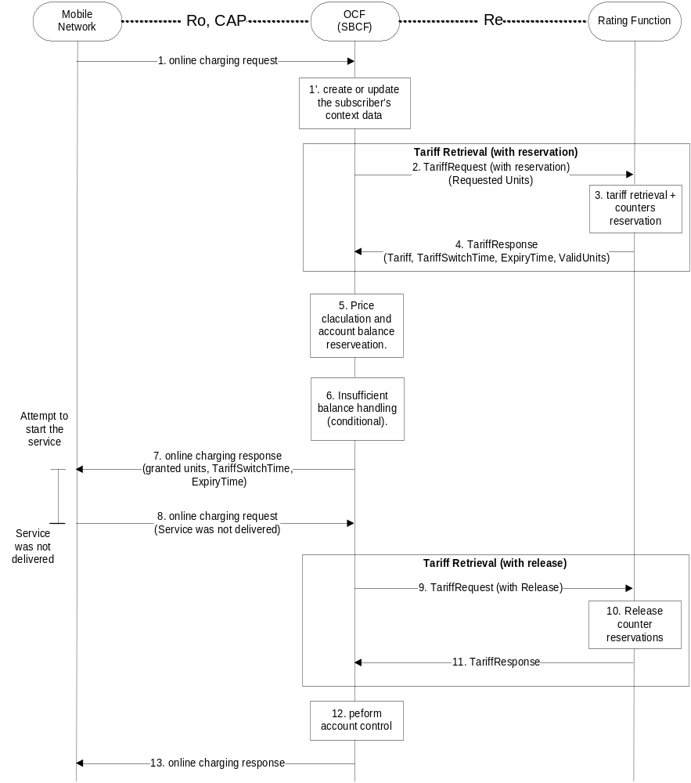
Figure : Tariff request scenario with service denial or unsuccessful delivery
Step 1-6: Repeat the same scenario in figure in subclause 6.2.2.2.1.
Step 7: Assuming a successful account balance reservation, the SBCF returns the granted units to the requesting network element. Otherwise, the service is being denied.
Step 8: The service is not delivered (e.g. the called party doesn't answer) and the network element informs the SBCF about the unsuccessful delivery. (If the service was denied on step 7, this step is omitted.)
Step 9: The SBCF sends a Tariff Request with a release instruction.
Step 10: The Rating Function releases the counters accordingly.
Step 11: The Rating Function acknowledges the operation to the SBCF.
Step 12: The SBCF performs final account control (i.e. releases account balance reservations). If the reservation failed already in step 6, this step is omitted.
Step 13: Finally, the SBCF sends an acknowledgment message to the serving network node in order to terminate the online charging dialogue.
In this scenario the service was not delivered in one of the following cases:
- Service denied –e.g. in the case of insufficient account balance.
- Service delivery unsuccessful –e.g. network failure or destination party doesn't answer.
Reservations made to the account balance and to counters are fully released. The charging function is using a tariff request message with a release request subtype to explicitly denote that the service was not delivered.

6.2.2.3 ServiceUsageRequest with reservation method
All message flows described in this section are applicable for the SBCF.
In the context of bearer charging or session charging, only the Session charging with unit reservation (SCUR) [50] is relevant. Therefore, only SCUR is considered in this section.
In the ServiceUsageRequest, a monetary quota is passed to the Rating Function and the response contains the allowed service units for this monetary quota.
The following figure describes the message flow for the service usage request method. The scenario describes the case where the SBCF invokes the ServiceUsageRequest method for charging several times during the same session, with reservation.
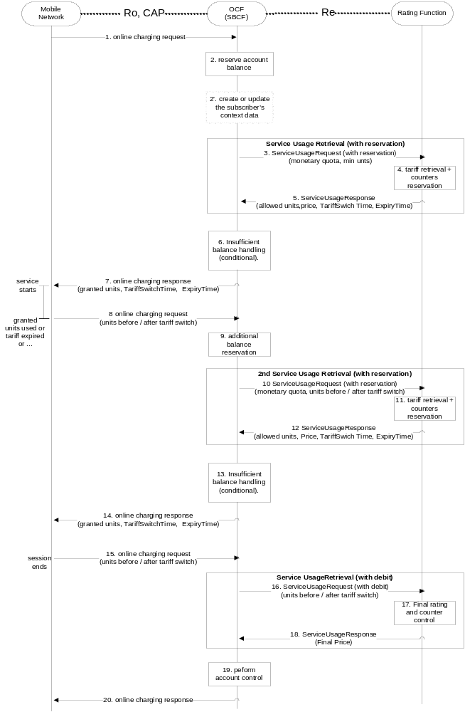
Figure : Service usage request method with reservation

Step 1: The SBCF receives an online charging request referring to an MS's bearer/session usage.
Step 2: The SBCF performs account balance reservation, based on the operator policy (typically the reservation will be service dependent). If there is insufficient balance, the available amount in the account balance is reserved.
Step 2' (Optional):In case there is no existing subscriber's context, the SBCF creates a new subscriber's context information. Otherwise, the SBCF updates the existing subscriber's context and get the list of active services for the given subscriber. This Step only applies when correlation is enabled.
Step 3: The SBCF requests the allowed usage of this service (service units) for the given monetary quota (i.e. the amount reserved from the account balance). The SBCF provides also a minimal number of requested service units.
Step 4: The Rating Function retrieves the appropriate tariff to be applied for the bearer/session. It calculates the number of service units that are allowed for the given monetary quota. If the calculated number of service units is lower than the minimal number of requested units for this service, the minimal requested units will be used. The Rating Function reserves counter values if needed and calculates the price. Note that the price may be different than the given monetary units (e.g. the user has free units from this service or the given monetary quota was insufficient for the minimal requested units from this service).
Step 5: The Rating Function returns the allowed usage, price and tariff information to the SBCF.
Step 6: If the Rating Function has returned a price which is higher than the initial account balance reservation (e.g. for a premium service), the charging function makes another reservation to meet the returned price.
Step 7: Assuming a successful account balance reservation, the SBCF returns the granted units to the requesting network element. Otherwise the service is denied.
Step 8: When the granted units have been used, a new request is send from the network element to the SBCF.
Step 9: Based on the tariff information and the price received in step 5 and the amount already reserved (either in step 2 or 6), the SBCF performs another account balance reservation.
Step 10-14: Repeat steps 3-7 .
Step 15: The session ends and a final charging request is issued with updated session details (e.g. exact session length).
Step 16: The SBCF sends a final service usage request with a debit instruction.
Step 17: The Rating Function performs final rating for the consumed resources and adjusts the counters accordingly.
Step 18: The Rating Function returns the final price to the SBCF.
Step 19: Based on the received price, the SBCF performs final account control.
Step 20: Finally, the SBCF sends an acknowledgment message to the serving network node in order to terminate the online charging dialogue.
In this scenario a service usage message request is send for every online charging request. The sequence of steps 8-13 can be repeated multiple times. Between any repetitions of those sequences, the charging session parameters that are relevant for rating may change. The change can be solicited (e.g. tariff switch) or unsolicited (e.g. QoS change). The network element shall issue another charging request in those cases i.e. on expiry time if tariff switch occurred, when granted units are consumed or when the QoS is changed. In all those cases, the charging function, sends information on both, the passed quota and the new quota. Specifically, when a tariff switch occurred, the charging function shall pass the consumed units before and after to the tariff switch in the following tariff request method. The rating function adjusts the reserved counters if needed as a result from the new information from the SBCF. The rating function makes new counters reservations for the next quota and returns the allowed number of service units for the next quota.
To allow for correct charging of this kind of scenarios, the rating function needs to make sure that all tariff information contained in a TariffResponse message expires between the next two tariff switches, i.e. between the tariff switch time that is defined within this TariffResponse message and the next subsequent tariff switch time. For this purpose, a parameter ExpiryTime is used. The ExpiryTime defines, how long the tariff information contained in the TariffResponse message is valid after the timestamp of the TariffRequest that triggered this response. For the handling of multiple tariff switches, it is recommended to set the ExpiryTime to the difference between the next two tariff switch times.
It should be noted that the ExpiryTime may also be used when no tariff switch is foreseen, to ensure a subsequent tariff retrieval operation after a specified time period has passed.
The service usage request message contains the reserved monetary quota for the service. The monetary quota in the first service usage request message is predetermined in the SBCF (e.g. according to the service). The predetermined monetary quota shall be designed to be sufficient for a minimal service usage. In some cases (e.g. premium services), setting the monetary quota to meet a minimal service usage can not be guaranteed. Hence, the first service usage request contains also a minimal number of service units required. The Rating Function retrieves the appropriate tariff and calculates the allowed number of service units. The number of service units is calculated as the maximum of the minimal requested units and the number of units that can be consumed for the given monetary quota.
If the service is free of charge (e.g. the user has some free service units), the Rating Function may not allow the whole quantity at once. If the free service units are shared between several users, the rating function may break the allowed units to smaller quotas to enable sharing of the free service units between the users, based on the operators policy. The Rating Function returns also the accumulated price for the consumed service and the requested service in the current quota. The price is used by the Charging Function to determine if additional account balance reservation is needed.
Service denial is being handled in the same manner as in the tariff request scenario (see subclause 6.2.2.2.2 for details). If the service was not delivered at all for any reason, an explicit service usage request with a release request subtype is send from the charging function to the rating function.
After the first service usage request, subsequent service usage request messages can take into account the account balance and the applied tariff and try to optimize the monetary quota in order to minimize the number of service usage requests. The monetary quota is bounded by the account balance. Requesting service usage for a very low monetary quota can result in a small amount of granted service units. In this case, the SBCF may decide to deny the service and close the session with the actual number of service units consumed.
The allowed units are calculated as if consumed in the highest tariff available for the subscriber (e.g. if the volume tariff is time dependent, the price will be calculated as if the volume was consumed solely during the higher rate period). If the tariff is not time dependent, but volume dependent, the tariff steps will be taken into account in advance.
At the final service usage request message (with the debit indication), the counters are updated and the final service price is returned. The charging function is responsible to free any extra reservations made.

6.3 Sy Message Flows
Detailed Message flows between PCRF and OCS is specified in TS 29.213 [208].

7 Definition of charging information

7.1 Re Message Types and Formats

7.1.1 General guidelines

7.1.1.1 General Description of Data types and Message Formats
The messages and data types used on the Re interface are defined based on the Diameter base protocol [401]. The contents of the messages is defined in subclause 7.1.2. Primitive data types are used as defined in the specification of the Diameter base protocol [401]. The structure of more complex data types is defined in subclause 7.1.3. Details on the Diameter implementation of the Re interface are described in subclause 7.1.4.

7.1.1.2 Rating Function Class selection
Although the contents of the messages are almost identical, the handling of the messages in the Rating Function will be different depending on the class of Rating Function used in a network. To distinguish between both classes of Rating Functions, the parameter RequestSubType is used.
If a "Class A" Rating Function is used, the parameter RequestSubType will not be present, because there are no subtypes in this case.
If a "Class B" Rating Function is used, the parameter RequestSubType will always be present.

7.1.2 Methods

7.1.2.1 PriceRequest Method
This request type is used to determine the price for a given event.
The following tables indicate the contents of the PriceRequest and PriceResponse messages.
The column "Status" denotes, whether the field is 'mandatory' (M), 'optional' (O) or ‘not applicable’ (-). Optional means that this parameter shall in general be included if available; if special conditions apply in addition, then these conditions are described in the "Description" column.
The body of the PriceRequest message consists of the following fields.
Name | Status in class |  | Description | Example
Name | “A” | “B” | Description | Example
SessionID | M | M | Session identification, used to match the request / response.
ActualTime | M | M | Actual timestamp of the current request.
Subscription-Id | M | M | Identifies the Charged Party.  This element contains one of the following;  - MSISDN (E.164 format)  - IMSI (E.212 format)  - SIP-URL  - NAI  - private ID (i.e. operator specific).  The Subscription-Id is described in subclause 7.1.4.2.54. The definition is taken from IETF RRC 4006 [402].  Editor’s Note: Applicability of NAI for 3GPP needs to be checked.
Service-Rating | M | M | One or more service elements. If several services are rated with one request, this grouped element is included several times. The structure of Service-Rating element is described in subclause 7.1.3.1.

The body of the PriceResponse message from the Rating Engine consists of the following fields:
Name | Status in class |  | Description | Example
Name | “A” | “B” | Description | Example
SessionID | M | M | Session identification, used to match the request / response.
Service-Rating | M | M | One or more service elements. If several services are rated with one request, this grouped element is included several times. The structure of Service-Rating element is described in subclause 7.1.3.1.

7.1.2.2 TariffRequest Method
The following tables indicate the contents of the TariffRequest and TariffResponse messages.
The column "Status" denotes, whether the field is 'mandatory' (M), 'optional' (O) or ‘not applicable’ (-).Optional means that this parameter shall in general be included if available; if special conditions apply in addition, then these conditions are described in the "Description" column.
The body of the TariffRequest message consists of the following fields:
Name | Status in class |  | Description | Example
Name | “A” | “ B” | Description | Example
SessionID | M | M | Session identification, used to match the request / response.
FirstRequest | O | O | Indicates that this is the first TariffRequest within this rating dialogue.
BeginTime | O | O | Event-timestamp of service activation request.
ActualTime | M | M | Actual timestamp of the current request.
Subscription-Id | M | M | Identifies the Charged Party.  This element contains one of the following;  - MSISDN (E.164 format)  - IMSI (E.212 format)  - SIP-URL  - NAI  - private ID (i.e. operator specific).  The Subscription-Id is described in subclause 7.1.4.2.54. The definition is taken from IETF RRC 4006 [402].  Editor’s Note: Applicability of NAI for 3GPP needs to be checked.
Service-Rating | M | M | One or more service elements. If several services are rated with one request, this grouped element is included several times. The structure of Service-Rating element is described in subclause 7.1.3.1.

The body of the TariffResponse message from the Rating Engine consists of the following fields:
Name | Status in class |  | Description | Example
Name | “A” | “B” | Description | Example
SessionID | M | M | Session identification, used to match the request / response.
Service-Rating | M | M | One or more service elements. If several services are rated with one request, this grouped element is included several times. The structure of Service-Rating element is described in subclause 7.1.3.1.

7.1.2.3 ServiceUsageRequest Method
The ServiceUsageRequest Method is implemented only if Class B rating function is used.
The following tables indicate the contents of the ServiceUsageRequest and ServiceUsageResponse messages.
The column "Status" denotes, whether the field is 'mandatory' (M), 'optional' (O) or ‘not applicable’ (-). Optional means that this parameter shall in general be included if available; if special conditions apply in addition, then these conditions are described in the "Description" column.
The body of the ServiceUsageRequest message consists of the following fields:
Name | Status in class |  | Description | Example
Name | “A” | “B” | Description | Example
SessionID | - | M | Session identification, used to match the request / response.
BeginTime | - | O | Event-timestamp of service activation request.
ActualTime | - | M | Actual timestamp of the current request.
Subscription-Id | - | M | Identifies the Charged Party.  This element contains one of the following;  - MSISDN (E.164 format)  - IMSI (E.212 format)  - SIP-URL  - NAI  - private ID (i.e. operator specific).  The Subscription-Id is described in subclause 7.1.4.2.54. The definition is taken from IETF RRC 4006 [402].  Editor’s Note: Applicability of NAI for 3GPP needs to be checked.
Service-Rating | M | M | One or more service elements. If several services are rated with one request, this grouped element is included several times. The structure of Service-Rating element is described in subclause 7.1.3.1.

The body of the ServiceUsageResponse message from the Rating Engine consists of the following fields:
Name | Status in class |  | Description | Example
Name | “A” | “B” | Description | Example
SessionID | - | M | Session identification, used to match the request / response.
Service-Rating | M | M | One or more service elements. If several services are rated with one request, this grouped element is included several times. The structure of Service-Rating element is described in subclause 7.1.3.1.

7.1.3 Parameter Definitions

7.1.3.1 Common Parameters
The DestinationID type has the following structure:
Name | Status | Description | Example
DestinationIDType | M | Type of Subscriber information contained in the DestinationIDData element.  Supported are the following types:  MSISDN, APN, URL, e-mail address,...  Editor’s note: Further types are TBD.
DestinationIDData | M | Identifies the destination, to which the requested service is directed.  This element contains one of the following;  - Number (E.164 format, e.g. MSISDN)  - APN  - URL  - e-mail address  - private ID (i.e. operator specific).

The Service-Rating type has the following structure:

Name | Status in class |  | Description | Available
Name | “A” | “B” | Description | PRQ | PRS | TRQ | TRS | SUQ | SUS
Service-Identifier | M | M | Identifies the service for which the online charging request was sent.  If M-S-R AVP is not present, this AVP is mandatory. | X | X | X | X | X | X
DestinationID | O | O | The structure of an individual DestinationID element is described in subclause 7.1.3.1.  Multiple occurrences of this element are possible. | X |  | X |  | X
ServiceInformation | O | O | The structure of a ServiceInformation element is defined in the middle-tier documents and formally specified in TS 32.299 [50]. The content of this parameter corresponds to the service indicated by the ServiceIdentifier. | X |  | X
Extension | O | O | Subscriber or operator-specific information, e.g. contract parameters. The format and content is out of scope for 3GPP standards. | X | X | X | X | X | X
Counter | O | - | One or multiple Counter elements.  The structure of an individual Counter element is described in subclause 7.1.3.2 | X |  | X
BasicPriceTimeStamp | O | - | The timestamp of the last charging of the Basic Price, if applicable for the service indicated by the ServiceID. | X |  | X
RequestSubType | - | M | Request sub type as described in subclause 7.1.3.3. | X |  | X |  | X
Price | M | M | Price for the requested service. |  | X |  | X |  | X
BillingInfo | O | O | Textual description for bill presentation. |  | X |  | X |  | X
BasicPrice | O | - | Basic Price for the requested service, e.g. basic fee once per day. |  | X |  | X
CounterPrice | O | - | One or multiple CounterPrice elements. The structure of an individual CounterPrice element is described in subclause 7.1.3.2. |  | X
ImpactOn  Counter | - | O | Description of the impacted counters. This parameter is being used only in the result of a  request with a debit request subtype. The structure of an individual impact on counter element is described in subclause 7.1.3.3. Multiple occurrences of this element might be used. |  | X |  | X |  | X
RequestedUnits | - | O | The number of requested units from the service. This parameter is mandatory in a request with reservation request subtype. |  |  | X
ConsumedUnits | - | O | The total number of consumed units of the service since previous request. |  |  | X |  | X
ConsumedUnits  AfterTariffSwitch | - | O | The number of consumed units of the service since previous request after tariff switch occurred. This parameter is mandatory if the tariff switch occurred since the previous request. |  |  | X |  | X
TariffSwitchTime | O | O | Time in Seconds from the time in parameter ActualTime of the TariffRequest until a tariff switch occurs.  '0' means immediately (the second tariff is valid). |  |  |  | X |  | X
Current-Tariff | M | O | Tariff that are currently valid. Tariff structure is defined in [50].  Class "B": This parameter is mandatory in the response message after a request with reservation subtype. |  |  |  | X |  | X
Next-Tariff | O | O | Tariff after the next TariffSwitch  Tariff structure is defined in [50]. |  |  |  | X |  | X
ExpiryTime | O | O | Time period in seconds from the time in parameter ActualTime of the TariffRequest until the expiration of all tariff information contained in this TariffResponse message.  This field may be used e.g. if multiple TariffSwitches are foreseen, or if interworking between limited valid units and TariffSwitches needs to be ensured. |  |  |  | X |  | X
ValidUnits | O | O | Defines for how many units the tariff is valid. |  |  |  | X
MonetaryTariffAfterValidUnits | O | O | Tariff after all valid units have been used.  Tariff structure is defined in subclause 7.1.4.2.45.  This field may be used to optimize service availability in scenarios with limited valid units. |  |  |  | X
CounterTariff | O | - | One or multiple CounterTariff elements. The structure of an individual CounterTariff element is described in subclause 7.1.3.2. |  |  |  | X
RequestedCounter | O | - | One or multiple CounterIDs. Only the counters identified in this list shall be included by the SBCF in subsequent TariffRequest messages within this session. The list is valid until a modified list is received by the SBCF or until the session ends. |  |  |  | X
MonetaryQuota | - | O | Number of monetary units reserved for the service usage. Mandatory in a reservation request subtype. |  |  |  |  | X
Minimal  RequestedUnits | - | O | The minimal number of requested units from the service. This parameter is mandatory in the first request with reservation request subtype. |  |  |  |  | X
AllowedUnits | - | O | Defines how many units can be granted for this monetary quota. Returning the AllowedUnits is mandatory in the reservation and AoC request subtypes. |  |  |  |  |  | X

7.1.3.2 Class “A” specific Parameters
The Counter type has the following structure:
Name | Status | Description | Example
CounterID | M | Identifies the Counter (i.e. used to address the counter).
CounterValue | O | The actual current value of the Counter. | 17
CounterExpiryDate | O | Timestamp for the expiration date of the current counter value.

The CounterPrice type has the following structure:
Name | Status | Description | Example
CounterID | M | Identifies the Counter (i.e. used to address the counter).
CounterType | O | Operator specific value, for descriptive purposes.
CounterChange | O | Value with which the counter shall be incremented or decremented. | -2
SetCounterTo | O | Value, to which the counter shall be set. | 50
CounterExpiryDate | O | Timestamp for the expiration date of the current counter value.

The CounterTariff type has the following structure:
Name | Status | Description | Example
CounterID | M | Identifies the Counter (i.e. used to address the counter).
CounterType | O | Operator specific value, for descriptive purposes.
CounterChangePerSession | O | Value, with which the counter shall be incremented or decremented for the whole session. | 4
CounterChangePerConsumedServiceUnit | O | Value, with which the counter shall be incremented or decremented per consumed service unit. | -1
CounterChangeForFirstChargeableTimeUnit | O | Value, with which the counter shall be incremented or decremented for the first chargeable unit (as defined by  E-parameter E7 from MonetaryTariff). | -2
CounterChangePerSubsequentChargeableTimeUnit | O | Value, with which the counter shall be incremented or decremented per chargeable unit (as defined by  E-parameter E2 from MonetaryTariff, i.e. except for the first unit). | -1
CounterChangePerChargeableVolumeUnit | O | Value, with which the counter shall be incremented or decremented per chargeable unit (as defined by  E-parameter E6 from MonetaryTariff). | 3
CounterChangeForFirstChargeableTimeUnitAfterSwitch | O | Value, with which the counter shall be incremented or decremented for the first chargeable unit after a Tariff Switch has occurred (as defined by E-parameter E7 from NextMonetaryTariff). | -4
CounterChangePerSubsequentChargeableTimeUnitAfterSwitch | O | Value, with which the counter shall be incremented or decremented per chargeable unit after a Tariff Switch has occurred (as defined by E-parameter E2 from NextMonetaryTariff, i.e. except for the first unit). | -1
CounterChangePerChargeableVolumeUnitAfterSwitch | O | Value, with which the counter shall be incremented or decremented per chargeable unit after a Tariff Switch has occurred (as defined by E-parameter E6 from NextMonetaryTariff). | 5
CounterThreshold | O | Threshold value for this counter. If this threshold is reached, all tariff information contained in this TariffResponse message expires, and the Charging Function shall sent a new TariffRequest message. | 30
SetCounterTo | O | Value, to which the counter shall be set. | 50
CounterExpiryDate | O | Timestamp for the expiration date of the current counter value.

7.1.3.3 Class “B” specific Parameters
The parameter RequestSubType can have the following values:
- AoC - Advice of Charge. In this sub-type, there is no counter reservation and no counter updates by the Rating Function.
- Reservation - This Price Request sub-type is used at event authorization time, prior to granting a service to a user. The Rating Function will reserve counters as needed according to the request. A Price Request with a Debit sub-type should follow after a service successful delivery or a Release sub-type in case the delivery failed.
- Debit - This Price Request sub-type is issued when a session ends or a service was granted successfully to a user, in order to debit a previously reservation request. The Rating Function will free any unused portion of an outstanding counter reservation. Note that multiple Price Requests with a Debit sub-type can be sent during a session for partial charging.
- Release - This Price Request sub-type is issued when a service delivery failed to release a previously reserved amount. The Rating Function will free any outstanding counter reservation.
The following tables summarize the parameters' presence in the various methods and messages. For each request subtype, the column denotes, whether the field is 'mandatory' (M), 'optional' (O) or ‘not applicable’ (-).
Parameter presence in the PriceRequest message:
Name | Reservation | Debit | Release
SessionID | M | M | M
ActualTime | M | M | O
Subscription-Id | M | - | -
Service-Identifier | M | - | -
DestinationID | O | O | -
ServiceInformation | O | O | -
Extension | O | O | O
RequestSubType | M | M | M

Parameter presence in the PriceResponse message:
Name | Reservation | Debit | Release
SessionID | M | M | M
Price | M | M | M
BillingInfo | - | O | O
Extension | O | O | O
BasicPrice | - | - | -
CounterPrice | - | - | -
ImpactOn  Counter | - | O | -

Parameter presence in the TariffRequest message:
Name | Reservation | Debit | Release
SessionID | M | M | M
FirstRequest | - | - | -
BeginTime | O | - | -
ActualTime | M | M | M
Subscription-Id | M | - | -
Service-Identifier | M | - | -
DestinationID | O | O | -
ServiceInformation | O | O | -
Extension | O | O | O
Counter | - | - | -
BasicPriceTimeStamp | - | - | -
RequestSubType | M | M | M
RequestedUnits | M | - | -
ConsumedUnits | O | M | -
ConsumedUnits  AfterTariffSwitch | O | O | -

Parameter presence in the TariffResponse message:
Name | Reservation | Debit | Release
SessionID | M | M | M
TariffSwitchTime | O | - | -
Current-Tariff | M | - | -
Next-Tariff | O | - | -
ExpiryTime | O | - | -
ValidUnits | O | - | -
MonetaryTariffAfterValidUnits | - | - | -
BillingInfo | - | O | -
Extension | O | O | O
CounterTariff | - | - | -
RequestedCounter | - | - | -
BasicPrice | - | - | -
Price | - | M | -
ImpactOn  Counter | - | O | -

Parameter presence in the ServiceUsageRequest message:
Name | Reservation | Debit | Release
SessionID | M | M | M
BeginTime | O | - | -
ActualTime | M | - | -
Subscription-Id | M | M | M
Service-Identifier | M | - | -
DestinationID | O | O | -
ServiceInformation | O | O | -
MonetaryQuota | O | O | -
Minimal  RequestedUnits | O | - | -
Extension | O | O | O
RequestSubType | M | M | M
ConsumedUnits | O | M | -
ConsumedUnits  AfterTariffSwitch | O | O | -

Parameter presence in the ServiceUsageResponse message:
Name | Reservation | Debit | Release
SessionID | M | M | M
TariffSwitchTime | O | - | -
Current-Tariff | M | - | -
Next-Tariff | O | - | -
ExpiryTime | O | - | -
AllowedUnits | O | - | -
Price | M | M | -
BillingInfo | - | O | -
ImpactOn  Counter | - | O | -
Extension | - | O | O

The ImpactOnCounter type has the following structure:
Name | Status | Description | Example
CounterID | M | Identifies the Counter (i.e. used to address the counter).
CounterValueBegin | O | The counter value at the beginning of the online charging session. | 17
CounterValueChange | M | The change in the counter value as result of the current online charging session. | -4
CounterValueEnd | O | The counter value at the end of the online charging session. Note that this value may be different from the value at the beginning of the online charging session plus the value change in case of concurrent service consumption. | 11

7.1.4 Diameter protocol specification
The messages for the Re interface, their formats and their contents are defined in terms of the Diameter Rating Application, a new 3GPP specific Diameter application based on the Diameter base protocol [401]. The application ID for the Diameter Rating Application is defined in TS 29.230 [205].
The messages for the Re interface are defined in the following subclause 7.1.4.1. These are new messages that are not included in the Diameter base protocol, however, relevant AVPs from the Diameter base protocol are included in the definition of these messages. Additional AVPs which are required for the functionality of the Re interface are also included. These additional AVPs are explained in detail in subclause 7.1.4.2.
Editor's Note: We have to define Finite State Machines (for class "A" only for the OCFs, for class "B" for both, OCFs and RF)?
Editor's Note: Error handling needs to be defined (separate subclause).

7.1.4.1 Diameter Rating messages on the Re interface
The table below describes the use of messages on the Re interface. Details on the use of these messages can be found in subclause 6.2 of this document.
Command-Name | Source | Destination | Abbreviation | Command-Code
PriceRequest | EBCF | RF | PRQ
PriceResponse | RF | EBCF | PRS
TariffRequest | SBCF | RF | TRQ
TariffResponse | RF | SBCF | TRS
ServiceUsageRequest | SBCF | RF | SUQ
ServiceUsageResponse | RF | SBCF | SUS

Editor's Note: Command codes shall be defined by CN4, and shall be included in 3GPP TS 29.230.
Editor's Note: Do we have to include (some of the) other messages defined in the Diameter base protocol?
The following subclauses describe the structure of the individual messages on the Re interface. The descriptions are based directly on the format of the Accounting-Request and Accounting-Answer messages defined in the base Diameter protocol specification [401].
The following symbols are used in the tables:
- <AVP> indicates a mandatory AVP with a fixed position in the message.
- {AVP} indicates a mandatory AVP in the message.
- [AVP] indicates an optional AVP in the message.
- *AVP indicates that multiple occurrences of an AVP are possible.

7.1.4.1.1 PriceRequest message
The Diameter PriceRequest message as used on the Re interface has the following structure.
<PRQ> :: = <Diameter Header: xxx, REQ, PXY>
<Session-Id>
{Origin-Host}
{Origin-Realm}
{Destination-Realm}
[Destination-Host]
[Vendor-Specific-Application-Id]
[User-Name]
[Event-Timestamp]
{ActualTime}
{Subscription-Id}
*{Service-Rating}
Editor's Note: Check if all included AVPs from the Diameter base protocol are needed.
Check if additional AVPs from the Diameter base protocol must be included.

7.1.4.1.2 PriceResponse message
The Diameter PriceResponse message as used on the Re interface has the following structure.
<PRS> :: = <Diameter Header: xxx, PXY>
<Session-Id>
{Origin-Host}
{Origin-Realm}
[Vendor-Specific-Application-Id]
[User-Name]
[Event-Timestamp]
*{Service-Rating}
Editor's Note: Check if all included AVPs from the Diameter base protocol are needed.
Check if additional AVPs from the Diameter base protocol must be included.

7.1.4.1.3 TariffRequest message
The Diameter TariffRequest message as used on the Re interface has the following structure.
<TRQ> :: = <Diameter Header: xxx, REQ, PXY>
<Session-Id>
{Origin-Host}
{Origin-Realm}
{Destination-Realm}
[Destination-Host]
[Vendor-Specific-Application-Id]
[User-Name]
[Event-Timestamp]
[FirstRequest]
[BeginTime]
{ActualTime}
{Subscription-Id}
*{Service-Rating}

Editor's Note: Check if all included AVPs from the Diameter base protocol are needed.
Check if additional AVPs from the Diameter base protocol must be included.

7.1.4.1.4 TariffResponse message
The Diameter TariffResponse message as used on the Re interface has the following structure.
<TRS> :: = <Diameter Header: xxx, PXY>
<Session-Id>
{Origin-Host}
{Origin-Realm}
[Vendor-Specific-Application-Id]
[User-Name]
[Event-Timestamp]
*{Service-Rating}
Editor's Note: Check if all included AVPs from the Diameter base protocol are needed.
Check if additional AVPs from the Diameter base protocol must be included.

7.1.4.1.5 ServiceUsageRequest message
The Diameter ServiceUsageRequest message as used on the Re interface has the following structure.
<SUQ> :: = <Diameter Header: xxx, REQ, PXY>
<Session-Id>
{Origin-Host}
{Origin-Realm}
{Destination-Realm}
[Destination-Host]
[Vendor-Specific-Application-Id]
[User-Name]
[Event-Timestamp]
[BeginTime]
{ActualTime}
{Subscription-Id}
*{Service-Rating}
Editor's Note: Check if all included AVPs from the Diameter base protocol are needed.
Check if additional AVPs from the Diameter base protocol must be included.
Editor's Note: Check if the order of the AVPs is aligned with the tariff request.

7.1.4.1.6 ServiceUsageResponse message
The Diameter ServiceUsageResponse message as used on the Re interface has the following structure.
<SUS> :: = <Diameter Header: xxx, PXY>
<Session-Id>
{Origin-Host}
{Origin-Realm}
[Vendor-Specific-Application-Id]
[User-Name]
[Event-Timestamp]
*{Service-Rating}
Editor's Note: Check if all included AVPs from the Diameter base protocol are needed.
Check if additional AVPs from the Diameter base protocol must be included.
Editor's Note: Check if the order of the AVPs is aligned with the tariff response.

7.1.4.2 AVPs for Rating on the Re interface
The use of the Attribute Value Pairs (AVPs) that are defined in the Diameter Base Protocol [401] is specified in
subclause 7.1.4.1 for the Re interface. Detailed specification of these AVPs is available in the Diameter base protocol specification.
Editor’s Note: “The 3GPP Rating Application uses the value xxx (3GPP) as Vendor-Id.” – Do we need this ?
Additional AVPs which are not included in the Diameter base protocol are used for rating purposes in all messages on the Re interface. The use of these AVPs is described in subclause 7.1.4.1.
Detailed descriptions of AVPs that are used specifically for online rating are provided in the subclauses below the table. The table contains all AVPs used for the Diameter Rating application, in alphabetical order. For AVPs that are just borrowed from other applications only the reference is provided in the table below, and the detailed description is not repeated.
AVP Name | AVP Code | Data Type | Description / Reference
AVPs from Diameter base protocol
[Destination-Host] |  |  | [401]
{Destination-Realm} |  |  | [401]
[Event-Timestamp] |  |  | [401]
{Origin-Host} |  |  | [401]
{Origin-Realm} |  |  | [401]
<Session-Id> |  |  | [401]
[User-Name] |  |  | [401]
[Vendor-Specific-Application-Id] |  |  | [401]
General Diameter Rating AVPs
{ActualTime} | TBD | Time | subclause 7.1.4.2.1
[BeginTime] | TBD | Time | subclause 7.1.4.2.5
[FirstRequest] | TBD | Enumerated | subclause 7.1.4.2.41
*{Service-Rating} | TBD | Grouped
{Service-Identifier} | TBD | UTF8String | subclause 7.1.4.2.53; [402]
* [DestinationID] | TBD | Grouped | subclause 7.1.4.2.29
{DestinationIDType} | TBD | Enumerated | subclause 7.1.4.2.31
{DestinationIDData} | TBD | UTF8String | subclause 7.1.4.2.30
[ServiceInformation] | TBD | Grouped | Subclause 7.1.4.2.54
[Extension] | TBD | Grouped | subclause 7.1.4.2.40
[Price] | TBD | Unsigned32 | Subclause7.1.4.2.48;  mandatory in PRS, optional in TRS
[BillingInfo] | TBD | UTF8String | subclause 7.1.4.2.6
[TariffSwitchTime] | TBD | Unsigned32 | subclause 7.1.4.2.59
{Current-Tariff} | TBD | Grouped | As defined in [50]
[Next-Tariff] | TBD | Grouped | As defined in [50]
[ExpiryTime] | TBD | Unsigned32 | subclause 7.1.4.2.39
[ValidUnits] | TBD | Unsigned32 | subclause 7.1.4.2.60
[MonetaryTariffAfterValidUnits] | TBD | Grouped | subclause 7.1.4.2.45
{Subscription-Id} | TBD | Grouped | subclause 7.1.4.2.56
{Subscription-Id-Type} | TBD | Enumerated | subclause 7.1.4.2.58
{Subscription-Id-Data} | TBD | UTF8String | subclause 7.1.4.2.57; [402]
Class A specific Diameter Rating AVPs
*{Service-Rating} | TBD | Grouped
* [Counter] | TBD | Grouped | subclause 7.1.4.2.9
{CounterID} | TBD | Unsigned32 | subclause 7.1.4.2.20
[CounterValue] | TBD | Integer32 | subclause 7.1.4.2.25
[CounterExpiryDate] | TBD | Time | subclause 7.1.4.2.19
[BasicPriceTimeStamp] | TBD | Time | subclause 7.1.4.2.4
[BasicPrice] | TBD | Unsigned32 | subclause 7.1.4.2.3
* [CounterPrice] | TBD | Grouped | subclause 7.1.4.2.21
{CounterID} | TBD | Unsigned32 | subclause 7.1.4.2.20
[CounterType] | TBD | Unsigned32 | subclause 7.1.4.2.24
[CounterChange] | TBD | Integer32 | subclause 7.1.4.2.10
[SetCounterTo] | TBD | Integer32 | subclause 7.1.4.2.55
[CounterExpiryDate] | TBD | Time | subclause 7.1.4.2.19
* [CounterTariff] | TBD | Grouped | subclause 7.1.4.2.22
{CounterID} | TBD | Unsigned32 | subclause 7.1.4.2.20
[CounterType] | TBD | Unsigned32 | subclause 7.1.4.2.24
[CounterChangePerSession] | TBD | Integer32 | subclause 7.1.4.2.16
[CounterChangePerConsumed ServiceUnit] | TBD | Integer32 | subclause 7.1.4.2.15
[CounterChangeForFirst ChargeableTimeUnit] | TBD | Integer32 | subclause 7.1.4.2.11
[CounterChangePerSubsequent ChargeableTimeUnit] | TBD | Integer32 | subclause 7.1.4.2.17
[CounterChangePerChargeable VolumeUnit] | TBD | Integer32 | subclause 7.1.4.2.13
[CounterChangeForFirst ChargeableTimeUnitAfterSwitch] | TBD | Integer32 | subclause 7.1.4.2.12
[CounterChangePerSubsequent ChargeableTimeUnitAfterSwitch] | TBD | Integer32 | subclause 7.1.4.2.18
[CounterChangePerChargeable VolumeUnitAfterSwitch] | TBD | Integer32 | subclause 7.1.4.2.14
[CounterThreshold] | TBD | Integer32 | subclause 7.1.4.2.23
[SetCounterTo] | TBD | Integer32 | subclause 7.1.4.2.55
[CounterExpiryDate] | TBD | Time | subclause 7.1.4.2.19
* [RequestedCounters] | TBD | Unsigned32 | subclause 7.1.4.2.50
Class B specific Diameter Rating AVPs
*{Service-Rating} | TBD | Grouped
[RequestSubType] | TBD | Enumerated | subclause 7.1.4.2.52
[ImpactonCounter] | TBD | Grouped | subclause 7.1.4.2.42
{CounterID} | TBD | Unsigned32 | subclause 7.1.4.2.20
[CounterValueBegin] | TBD | Integer32 | subclause 7.1.4.2.26
[CounterValueChange] | TBD | Integer32 | subclause 7.1.4.2.27
[CounterValueEnd] | TBD | Integer32 | subclause 7.1.4.2.28
[RequestedUnits] | TBD | Unsigned32 | subclause 7.1.4.2.51
[ConsumedUnits] | TBD | Unsigned32 | subclause 7.1.4.2.7
[ConsumedUnitsAfterTariffSwitch] | TBD | Unsigned32 | subclause 7.1.4.2.8
[MonetaryQuota] | TBD | Unsigned32 | subclause 7.1.4.2.46
[MinimalRequestedUnits] | TBD | Unsigned32 | subclause 7.1.4.2.43
[AllowedUnits] | TBD | Unsigned32 | subclause 7.1.4.2.2

Editor's Note: AVP codes shall be defined by CN4, and shall be included in 3GPP TS 29.230.
Editor's Note: Check if definitions of some AVPs can be replaced by reference to IETF RRC 4006 [402].

7.1.4.2.1 ActualTime AVP
The ActualTime AVP is of type Time. It contains the actual timestamp of the current rating request message (i.e. PRQ or TRQ).
Editor's Note: Is this AVP necessary, or is the content equal to the Event-Timestamp AVP from Diameter base?

7.1.4.2.2 AllowedUnits AVP
The AllowedUnits AVP is of type Unsigned32. It defines how many service units the charging function can grant for the MonetaryQuota reserved.

7.1.4.2.3 BasicPrice AVP
The BasicPrice AVP is of type Unsigned32. It contains a basic fee, that is applicable e.g. only once per day. If the BasicPrice AVP is received by an online charging function, the charging function will deduct this price from the subscriber's Account Balance, and it will store the current system time internally as timestamp for the last charging of the Basic Price.

7.1.4.2.4 BasicPriceTimeStamp AVP
The BasicPriceTimeStamp AVP is of type Time. It contains the timestamp of the last charging of the Basic Price which is applicable for the service indicated in the current request.

7.1.4.2.5 BeginTime AVP
The BeginTime AVP is of type Time. It contains the timestamp of the service activation request from the network.

7.1.4.2.6 BillingInfo AVP
The BillingInfo AVP is of type UTF8String. It contains billing relevant information. The content of this AVP is operator specific and out of scope for 3GPP standards.

7.1.4.2.7 ConsumedUnits AVP
The ConsumedUnits AVP is of type Unsigned32. It defines how many service units were totally consumed since the previous TRQ or SUQ message. This information is being used by the RF to update counters and track the price.

7.1.4.2.8 ConsumedUnitsAfterTariffSwitch AVP
The ConsumedUnitsAfterTariffSwitch AVP is of type Unsigned32. It defines how many service units were totally consumed after tariff switch since the previous TRQ or SUQ message. If no tariff switch occurred, the value 0 shall be used. This information is being used by the RF to update counters and track the price.

7.1.4.2.9 Counter AVP
The Counter AVP is of type Grouped. It contains information related to a specified counter of the subscriber, as stored in the Account Balance Management Function. Multiple Counter AVPs can be included in one rating request message (i.e. PRQ or TRQ).
The Counter AVP has the following format:
Counter :: = < AVP Header: TBD>
{CounterID}
[CounterValue]
[CounterExpiryDate]

7.1.4.2.10 CounterChange AVP
The CounterChange AVP is of type Integer32. It contains the value, with which the addressed counter (as identified by the associated CounterID AVP) shall be incremented or decremented.

7.1.4.2.11 CounterChangeForFirstChargeableTimeUnit AVP
The CounterChangeForFirstChargeableTimeUnit AVP is of type Integer32. It contains the value, with which the addressed counter (as identified by the associated CounterID AVP) shall be incremented or decremented for the first chargeable time unit. The first chargeable time unit is defined by the EParameterE7 AVP in the MonetaryTariff AVP.

7.1.4.2.12 CounterChangeForFirstChargeableTimeUnitAfterSwitch AVP
The CounterChangeForFirstChargeableTimeUnitAfterSwitch AVP is of type Integer32. It contains the value, with which the addressed counter (as identified by the associated CounterID AVP) shall be incremented or decremented for the first chargeable time unit, if a tariff switch has occurred immediately at the beginning of the online charging session. In this case, the first chargeable time unit is defined by the EParameterE7 AVP in the Next-Tariff AVP.

7.1.4.2.13 CounterChangePerChargeableVolumeUnit AVP
The CounterChangePerChargeableVolumeUnit AVP is of type Integer32. It contains the value, with which the addressed counter (as identified by the associated CounterID AVP) shall be incremented or decremented per chargeable volume unit. The chargeable volume unit is defined by the EParameterE6 AVP in the Current-Tariff AVP.

7.1.4.2.14 CounterChangePerChargeableVolumeUnitAfterSwitch AVP
The CounterChangePerChargeableVolumeUnitAfterSwitch AVP is of type Integer32. It contains the value, with which the addressed counter (as identified by the associated CounterID AVP) shall be incremented or decremented per chargeable volume unit after a tariff switch has occurred. The chargeable volume unit is defined by the EParameterE6 AVP in the Next-Tariff AVP.

7.1.4.2.15 CounterChangePerConsumedServiceUnit AVP
The CounterChangePerConsumedServiceUnit AVP is of type Integer32. It contains the value, with which the addressed counter (as identified by the associated CounterID AVP) shall be incremented or decremented per consumed service unit.

7.1.4.2.16 CounterChangePerSession AVP
The CounterChangePerSession AVP is of type Integer32. It contains the value, with which the addressed counter (as identified by the associated CounterID AVP) shall be incremented or decremented once for the whole online charging session.

7.1.4.2.17 CounterChangePerSubsequentChargeableTimeUnit AVP
The CounterChangePerSubsequentChargeableTimeUnit AVP is of type Integer32. It contains the value, with which the addressed counter (as identified by the associated CounterID AVP) shall be incremented or decremented per chargeable time unit, except for the first chargeable time unit. The chargeable time unit is defined by the EParameterE2 AVP in the Current-Tariff AVP.

7.1.4.2.18 CounterChangePerSubsequentChargeableTimeUnitAfterSwitch AVP
The CounterChangePerSubsequentChargeableTimeUnitAfterSwitch AVP is of type Integer32. It contains the value, with which the addressed counter (as identified by the associated CounterID AVP) shall be incremented or decremented per chargeable time unit (except for the first chargeable time unit) after a tariff switch has occurred. In this case, the chargeable time unit is defined by the EParameterE2 AVP in the Next-Tariff AVP.

7.1.4.2.19 CounterExpiryDate AVP
The CounterExpiryDate AVP is of type Time. It contains the timestamp, at which the current value of the addressed counter (as identified by the associated CounterID AVP) expires.

7.1.4.2.20 CounterID AVP
The CounterID AVP is of type Unsigned32. It is used to address a specific counter, i.e. it identifies the counter. Therefore, the CounterID must be unique for each subscriber.

7.1.4.2.21 CounterPrice AVP
The CounterPrice AVP is of type Grouped. It is used in the PriceResponse message, and it contains information on how the online charging function shall modify a specified counter of the subscriber in the Account Balance Management Function.
The CounterPrice AVP has the following format:
CounterPrice :: = < AVP Header: TBD>
{CounterID}
[CounterType]
[CounterChange]
[SetCounterTo]
[CounterExpiryDate]

7.1.4.2.22 CounterTariff AVP
The CounterTariff AVP is of type Grouped. It is used in the TariffResponse message, and it contains information on how the online charging function shall modify a specified counter of the subscriber in the Account Balance Management Function.
The CounterTariff AVP has the following format:
CounterTariff :: = < AVP Header: TBD>
{CounterID}
[CounterType]
[CounterChangePerSession]
[CounterChangePerConsumedServiceUnit]
[CounterChangeForFirstChargeableTimeUnit]
[CounterChangePerSubsequentChargeableTimeUnit]
[CounterChangePerChargeableVolumeUnit]
[CounterChangeForFirstChargeableTimeUnitAfterSwitch]
[CounterChangePerSubsequentChargeableTimeUnitAfterSwitch]
[CounterChangePerChargeableVolumeUnitAfterSwitch]
[CounterThreshold]
[SetCounterTo]
[CounterExpiryDate]

7.1.4.2.23 CounterThreshold AVP
The CounterThreshold AVP is of type Integer32. It contains a threshold value for the addressed counter (identified by the associated CounterID AVP). If the value of the specified counter reaches this threshold value, all tariff information contained in the TRS message expires, and the Online Charging Function shall sent a new TRQ message to the Rating Function.

7.1.4.2.24 CounterType AVP
The CounterType AVP is of type Unsigned32. It contains an operator specific value which characterizes the addressed counter (identified by the associated CounterID AVP). The CounterType AVP is used only for descriptive purposes. In contrast to the CounterID AVP, the CounterType AVP may be not unique.

7.1.4.2.25 CounterValue AVP
The CounterValue AVP is of type Integer32. It contains the actual current value for the addressed counter (identified by the associated CounterID AVP) as stored in the Account Balance Management Function.

7.1.4.2.26 CounterValueBegin AVP
The CounterValueBegin AVP is of type Integer32. It contains the value for the addressed counter (identified by the associated CounterID AVP) at the beginning of the current online charging session.

7.1.4.2.27 CounterValueChange AVP
The CounterValueChange AVP is of type Integer32. It contains the change of the value for the addressed counter (identified by the associated CounterID AVP) as result of the current online charging session.

7.1.4.2.28 CounterValueEnd AVP
The CounterValueEnd AVP is of type Integer32. It contains the value for the addressed counter (identified by the associated CounterID AVP) at the end of the current online charging session.

7.1.4.2.29 DestinationID AVP
The DestinationID AVP is of type Grouped. It contains information about the destination of the service usage in the network (e.g. the called party in a telephony scenario). Multiple Destination AVPs can be included in one rating request message (i.e. PRQ or TRQ), if the service is directed towards multiple destinations (e.g. one SMS to multiple recipients).
The DestinationID AVP has the following format:
DestinationID :: = < AVP Header: TBD>
{DestinationIDType}
{DestinationIDData}

7.1.4.2.30 DestinationIDData AVP
The DestinationIDData AVP is of type UTF8String. Its contents identify the destination to which the requested service is directed (e.g. the called party in a telephony scenario, the recipient of an SMS, ...). The DestinationIDType AVP defines which type of identifier is used.
If an APN is included in the DestinationIDData AVP, it should be noted that 3GPP TS 23.003 [203] defines the APN with a maximum length of 100 octets, but 3GPP TS 29.002 [204] uses a length of 63.

7.1.4.2.31 DestinationIDType AVP
The DestinationIDType AVP is of type Enumerated. It is used inside the DestinationID AVP, and it indicates which kind of destination information is contained in this DestinationIDData AVP.
The following values are currently defined for the DestinationIDType AVP:
0: Destination_Number
1: Destination_APN
2: Destination_URL
3: Destination_EmailAddress
4: Destination_PrivateID

7.1.4.2.32 Void

7.1.4.2.33 Void

7.1.4.2.34 Void

7.1.4.2.35 Void

7.1.4.2.36 Void

7.1.4.2.37 Void

7.1.4.2.38 Void

7.1.4.2.39 ExpiryTime AVP
The ExpiryTime AVP is of type Unsigned32. It is used in the TRS message. It contains the time period in seconds from the time included in the ActualTime AVP of the corresponding TRQ message until all tariff information contained in this TRS message expires.
The online charging function shall start a timer whenever a TRQ message is sent (i.e. at the timestamp indicated in the ActualTime AVP of the TRQ message). When this timer reaches the value indicated in the ExpiryTime AVP of the TRS message that is received in response, the online charging function shall send a new TRQ message to the Rating Function.

7.1.4.2.40 Extension AVP
The Extension AVP is of type Grouped. Its purpose is to allow transmission of additional information elements not covered by this document, in order to meet operator-specific requirements.
The format and the contents of this AVP are vendor- and/or operator-specific. The definition of this AVP is out of scope for 3GPP standards.
Note that the format of the Extension AVP may be different in the various messages of the Diameter Rating Application (i.e. PRQ, PRS, TRQ, TRS).
Editor's Note: Check if the notation "* [AVP]" can be used alternatively.

7.1.4.2.41 FirstRequest AVP
The FirstRequest AVP is of type Enumerated. Its purpose is to indicate, whether this TariffRequest message is the first Tariff Request message within this rating dialogue, i.e. this message "initiates" the rating dialogue.
The following values are defined for the FirstRequest AVP:
0: Subsequent Request:
this is not the first Tariff Request message within this rating dialogue
1: First Request:
this is the first Tariff Request message in this rating dialogue
If the FirstRequest AVP is not included in a TariffRequest message, this shall be interpreted as a FirstRequest AVP set to "0", i.e. the TariffRequest is not the first request in this rating dialogue.

7.1.4.2.42 ImpactOnCounter AVP
The ImpactOnCounter AVP is of type Grouped. It contains information on how the counter has been modified as a result of the current online session. It is used by the Charging Data Function for inclusion in the CDRs (refer to subclause 7.2).
The ImpactOnCounter AVP has the following format:
ImpactOnCounter:: = < AVP Header: TBD>
{CounterID}
[CounterValueBegin]
{CounterValueChange}
[CounterValueEnd]

7.1.4.2.43 MinimalRequestedUnits AVP
The MinimalRequestedUnits AVP is of type Unsigned32. It defines the minimal number of service units the charging function intends to grant. This information is being used by the RF to calculate the allowed units and to reserve counters.

7.1.4.2.44 Void

7.1.4.2.45 MonetaryTariffAfterValidUnits AVP
The MonetaryTariffAfterValidUnits AVP is of type Grouped. It is used in the TariffResponse message, and it contains the tariff information that is valid after all valid units (as indicated in the ValidUnits AVP) have been used. This AVP may be used to optimize service availability in call scenarios involving a limited number of valid units (ref. to subsection 6.2.1.2.3 for details).
The MonetaryTariffAfterValidUnits AVP may only be included in a TRS message, if the ValidUnits AVP is also included in the same message.
The MonetaryTariffAfterValidUnits AVP has the same structure as Next-Tariff AVP.

7.1.4.2.46 MonetaryQuota AVP
The MonetaryQuota AVP is of type Unsigned32. It defines the amount of monetary units reserved by the charging function. The rating function calculates the amount of service units that can be consumed with this amount.

7.1.4.2.47 Service-Rating AVP
The Service-Rating AVP is of type Grouped. It is used in the all messages once if single service is rated or multiple times if several services are rated in a single transaction.
The Service-Rating AVP has the following format:
Service-Rating :: = < AVP Header: TBD>
{Service-Identifier}
*[DestinationID]
[ServiceInformation]
[Extension]
[Price]
[BillingInfo]
[TariffSwitchTime]
{MonetaryTariff}
[NextMonetaryTariff]
[ExpiryTime]
[ValidUnits]
[MonetaryTariffAfterValidUnits]
* [Counter]
[BasicPriceTimeStamp]
[BasicPrice]
* [CounterPrice]
* [CounterTariff]
* [RequestedCounters]
[RequestSubType]
[ImpactonCounter]
[RequestedUnits]
[ConsumedUnits]
[ConsumedUnitsAfterTariffSwitch]
[MonetaryQuota]
[MinimalRequestedUnits]
[AllowedUnits]

7.1.4.2.48 Void

7.1.4.2.49 Price AVP
The Price AVP is of type Unsigned32. It contains the price of the requested service.

7.1.4.2.50 RequestedCounter AVP
The RequestedCounter AVP is of type Unsigned32. An individual RequestedCounter AVP contains the ID of a counter (ref. 7.1.4.2.19). Multiple RequestedCounter AVPs may be included in one TRS message.
Only counters with CounterIDs included as a RequestedCounter AVP in a TRS message shall be included by the online charging function in subsequent TRQ messages within this session. The list of RequestedCounters is valid until a modified list is received by the online charging function in a subsequent TRS message or until the online charging session ends (i.e. if the list of requested counters does not change during the online charging session, the RequesedCounter AVPs must only be included in the first TRS message during this online charging session).

7.1.4.2.51 RequestedUnits AVP
The RequestedUnits AVP is of type Unsigned32. It defines how many service units the charging function intends to grant. This information is being used by the RF to reserve counters.

7.1.4.2.52 RequestSubType AVP
The RequestSubType AVP is of type Enumerated. It is used when class "B" rating function is used (for details see subclause 7.1.3.3).
The following values are currently defined for the RequestSubType AVP:
0: REQ_SUBTYPE_AOC
1: REQ_SUBTYPE_RESERVE
2: REQ_SUBTYPE_DEBIT
3: REQ_SUBTYPE_RELEASE

7.1.4.2.53 Service-Identifier AVP
Refer to IETF RRC 4006 [402] for details.

7.1.4.2.54 ServiceInformation AVP
The ServiceInformation AVP is defined in 3GPP TS 32.299.
Note that the Location Information is included inside the Service Information AVP.

7.1.4.2.55 SetCounterTo AVP
The SetCounterTo AVP is of type Integer32. It contains a value, to which the addressed counter (as identified by the associated CounterID AVP) shall be set. This AVP may be used, e.g., to reset counters.
Using the SetCounterTo AVP, the Rating Function can also trigger the creation of new counters: if the addressed counter does not exist, the Charging Function shall create this counter in the Account Balance Management Function and initialize it with the value contained in the SetCounterTo AVP.

7.1.4.2.56 Subscription-Id AVP
The Subscription-Id AVP is of type Grouped. It contains information which identifies the subscriber, to which the online charging session applies (i.e. the charged party).
The SubscriberID AVP has the following format:
Subscription-ID :: = < AVP Header: TBD>
{Subscription-Id-Type}
{Subscription-Id-Data}
Refer to IETF RRC 4006 [402] for details.

7.1.4.2.57 Subscription-Id-Data AVP
Refer to IETF RRC 4006 [402] for details.

7.1.4.2.58 Subscription-Id-Type AVP
The Subscription-Id-Type AVP is of type Enumerated. It is used inside the Subscription-Id AVP, and it indicates which kind of subscriber information is contained in this Subscription-Id AVP.
The following values are currently defined for the Subscription-Id-Type AVP:
0: END_USER_E164
1: END_USER_IMSI
2: END_USER_SIP_URI
3: END_USER_NAI
4: END_USER_PRIVATE
Refer to IETF RRC 4006 [402] for details.

7.1.4.2.59 TariffSwitchTime AVP
The TariffSwitchTime AVP is of type Unsigned32. It is used in the TRS message. It contains the time period in seconds from the time included in the ActualTime AVP of the corresponding TRQ message until the next tariff switch occurs. A value "0" of the TariffSwitchTime AVP means, that the tariff switch occurs immediately, i.e. the tariff information contained in the NextMonetaryTariff AVP is valid immediately.

7.1.4.2.60 ValidUnits AVP
The ValidUnits AVP is of type Unsigned32. It is used in the TRS message. It defines, for how many consumed service units the tariff information in this TRS message is valid. After the number of units defined in the ValidUnits AVP has been consumed by the subscriber, the online charging function shall send a new TRQ message to the Rating Function. If available, the online charging function may use the MonetaryTariffAfterValidUnits AVP to charge service consumption after all valid units have been consumed (ref. to subsection 6.2.1.2.3 for details).

7.2 OCS Charging data records
Only general requirements on the generation and the contents of OCS CDRs are described in the present document. The detailed implementation is vendor specific and may be standardized in a later release.

7.2.1 General description
OCS charging data records (CDRs) are created in the Charging Data Function (CDF), which is always integrated in the Online Charging Functions (i.e. EBCF, SBCF). The generation of an OCS CDR is triggered by the first incoming online charging request from the network. The record remains open during the complete online charging session. It is closed after the final online charging response is sent from the OCF to the network (refer to subsection 6.2 for a definition of online charging request and online charging response). Partial records may be supported for some scenarios, e.g. for packet switched bearer charging.
OCS CDRs are transferred immediately from the CDF to the Charging Gateway Function (CGF) via the Ga reference point. The CGF forwards CDRs via the Bo reference point to the operator's post-processing systems.
The following types of OCS charging data records shall be supported:
- in the scope of bearer level charging:
  - OCS CDR(s) for CS Charging
  - OCS CDR(s) for PS Charging
  - OCS CDR(s) for WLAN Charging
Note that bearer level charging also covers SMS.
- in the scope of subsystem level charging:
- OCS CDR(s) for IMS Charging
- in the scope of service (event) level charging:
- OCS CDR(s) for MMS Charging
- OCS CDR(s) for LCS Charging
- OCS CDR(s) for PoC Charging
- OCS CDR(s) for MBMS Charging
- OCS CDR(s) for SMS Charging
- OCS CDR(s) for MMTel Charging
Additional CDRs may be supported for further services.
OCS records include only data from the incoming online charging requests and internal data from the OCS. The following charging data are required in CDRs (if applicable for the online charging session):
- data relevant for charging from CAP messages (InitialDP, ApplyChargingReport, ...)
- data relevant for charging from Ro messages (Credit Control Request)
- tariff information received from the Rating Function
- call / session charges
- account balance at the end of the online charging session
- counter values at the beginning and at the end of the online charging session; optionally also the change of counter values that occurred due to the specific online charging session.
Note that inclusion of the change of counter values is especially important, when multiple online charging sessions can occur in parallel (e.g. when counters are shared among several subscribers).
It is not required that the OCS collects further information from systems outside the OCS just for inclusion in the records.
The Charging Gateway Function can be integrated with each of the Charging Functions (SBCF, EBCF), because all data necessary for the generation of OCS CDRs is already available in the Charging Functions.
OCS CDR files are transferred from the Charging Gateway Function to the operator's post-processing systems via the Bo reference point (see [1], [52] for details).

7.3 Sy Message Types and Formats
The messages and data types used on the Sy interface are specified in TS 29.219 [207].

Annex A (informative):
Bibliography
a) 3GPP charging specifications
- 3GPP TS 32.250: "Telecommunication management; Charging management; Circuit Switched (CS) domain charging".
- 3GPP TS 32.298: "Telecommunication management; Charging management; Charging Data Record (CDR) parameter description".
b) Common 3GPP specifications
-
c) Other Domain and Service specific 3GPP / ETSI specifications
-
d) Relevant ITU Recommendations
-
e) Relevant IETF RFCs
-

Annex B (informative):
Rc Reference Point Operator Guidance

B.1 Introduction
The present Annex describes the Rc reference point functionality, and its message flows, syntax definition when Diameter Credit Control application is used.
For guidance on how the Rc reference point can be realised by operators there are two options presentedon how to fulfil the Rc reference point. These are based on the re-use of existing 3GPP Diameter applications: an option based on the 3GPP Ro Diameter application which is same with Diameter Credit Control application and an option based on the 3GPP Re Diameter application. The Ro-based alternative can be used when no counters are in use or are managed by the Rating Function (RF) (RF is Class B). If counters are managed by ABMF (RF is Class A), the Re-based alternative is the appropriate solution.
The Ro based approach is based on the Ro Diameter application as specified in TS 32.299 [50]. The Re based approach is based on the Re Diameter application as specified in clause 7.1.4.

B.2 Reference Point Functionality
Rc reference point implements following operations to access the AMBF:
- Immediate Account Debit Operation
In this operation the OCF immediately debits monetary units from the subscriber’s account in the ABMF. If counters are managed by the ABMF, the counters may be updated if needed.
- Event based Account Reservation with Debit / Release Operation
In this operation the OCF makes a reservation against the subscriber’s account. Upon service delivery completion the OCF makes the final debit. If counters are managed by the ABMF, counter reservations may be made with the monetary reservation and the counters are updated along with the final debit. If the service delivery fails, the credit reservation is released.
- Session based Account Reservation with Debit / Release Operation
In this operation the OCF makes a reservation against the subscriber’s account. The OCF may update the reservation along the progress of the service delivery. Upon service delivery completion the OCF makes the final debit. If counters are managed by the ABMF, counters reservation may be made with the monetary reservation and the counters are updated along with the associated debit. If the service delivery fails, the credit reservation is released.
- Account Refund Operation
In this operation the OCF refund monetary units to the subscriber’s account in the ABMF. If counters are managed by the ABMF, the counters may be updated if needed.
- Account Balance Query Operation
In this operation the OCF queries the subscriber’s account in the ABMF. If counters are managed by the ABMF, the counters' values are returned along with the balance.

B.3 Rc Reference Point Message Flows

B.3.1 Immediate Account Debit
The following figure describes an Immediate Account Debit scenario for the case when the EBCF interacts with an ABMF over an Rc reference point.
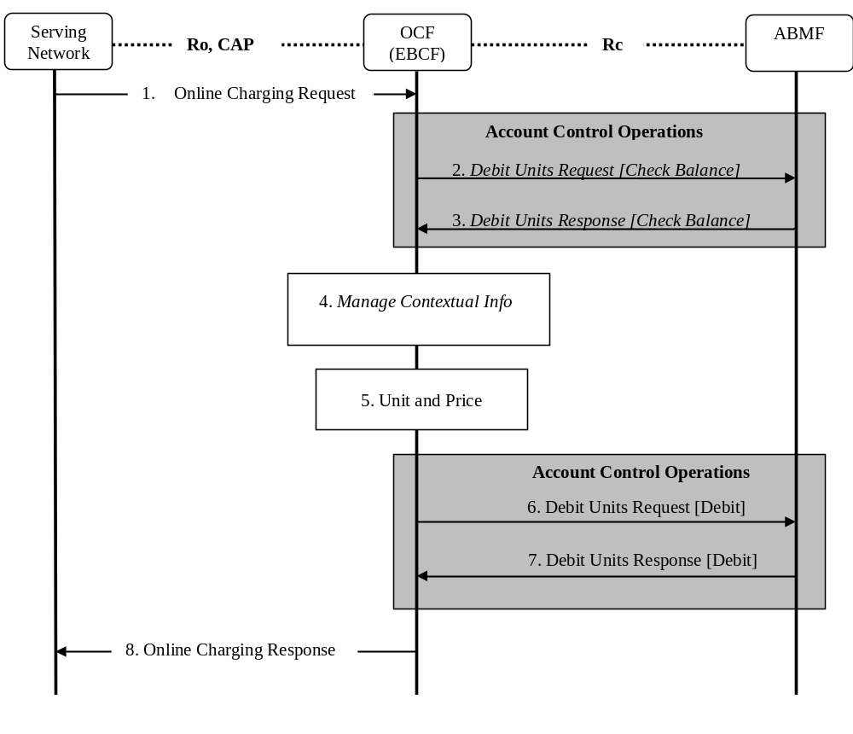
Figure B.3.1 - Immediate Account Debit
Step 1: The EBCF receives an online charging request for a certain event/service.

Steps 2 through 5 relate to unit and price determination.

Step 2(Optional): The EBCF requests account and counter information for the subscriber from the ABMF.
Only valid for Rating class “A”.
Step 3(Optional): The EBCF receives account and counter information for the subscriber from the Account Balance Management Function.
Only valid for Rating class “A”.
Step 4 (Optional): In case there is no existing subscriber's context, the EBCF creates a new subscriber's context information. Otherwise, the EBCF updates the existing subscriber's context and gets the list of active services for the given subscriber. This Step only applies when correlation is enabled.

Step 5: The EBCF determines the units and price of the requested service. This step particularly involves the Rating Function.
Step 6: The EBCF requests the ABMF to apply the (debit) operation the account. Counters update is performed for Rating class “A”.
Step 7: The EBCF receives the response to the (debit) request to apply the account.
Step 8: The EBCF sends the appropriate online charging response.

B.3.2 Event based Account Reservation with Debit or Release
The following figure describes an Event based Account Reservation with Debit or Release scenario for the case when the EBCF interacts with an ABMF over an Rc reference point.
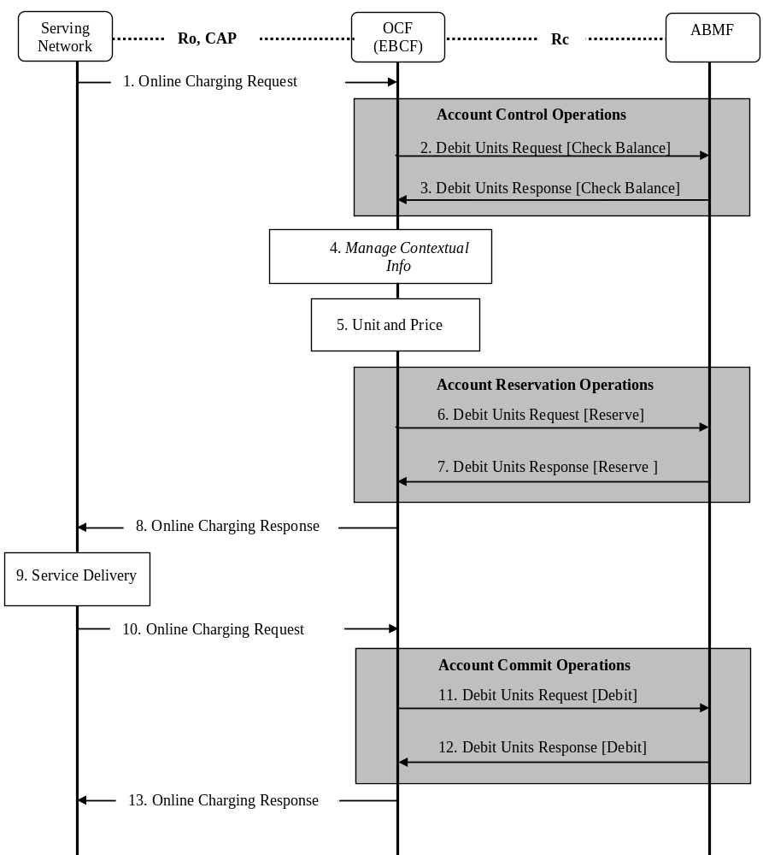
Figure B.3.2 - Event based Account Reservation with Debit or Release
Step 1: The EBCF receives an online charging request for a certain event/service.

Steps 2 through 5 relate to unit and price determination.

Step 2(Optional): The EBCF requests account and counter information for the subscriber from the Account Balance Management Function. Only valid for Rating class “A”.
Step 3(Optional): The EBCF receives account and counter information for the subscriber from the Account Balance Management Function. Only valid for Rating class “A”.
Step 4 (Optional): In case there is no existing subscriber's context, the EBCF creates a new subscriber's context information. Otherwise, the EBCF updates the existing subscriber's context and gets the list of active services for the given subscriber (see note below). This Step only applies when correlation is enabled.
Step 5: The EBCF determines the units and price of the requested service. This step particularly involves the Rating Function.
Step 6: The EBCF requests the ABMF to create reservations for the requested service.
Step 7: The EBCF receives the response to the request to create reservations for the requested service.
Step 8: The EBCF sends the appropriate online charging response.
Step 9: The service is delivered by the serving network.
Step 10: The serving network node sends an indication of service delivery status to the EBCF.
Step 11: The EBCF requests the ABMF to debit (or “release” if the service delivery status is unsuccessful) the reservations for the requested service. An additional “price” operation may be required prior to this step if indicated in step 10. Counters update is performed for Rating class “A”.
Step 12: The ABMF responds to the account (debit or release) operation request.
Step 13: The EBCF sends the appropriate online charging response.

B.3.3 Session based Account Reservation with Debit or Release
The following figure describes a Session based Account Reservation with Debit or Release scenario for the case when the SBCF interacts with an ABMF over an Rc reference point.
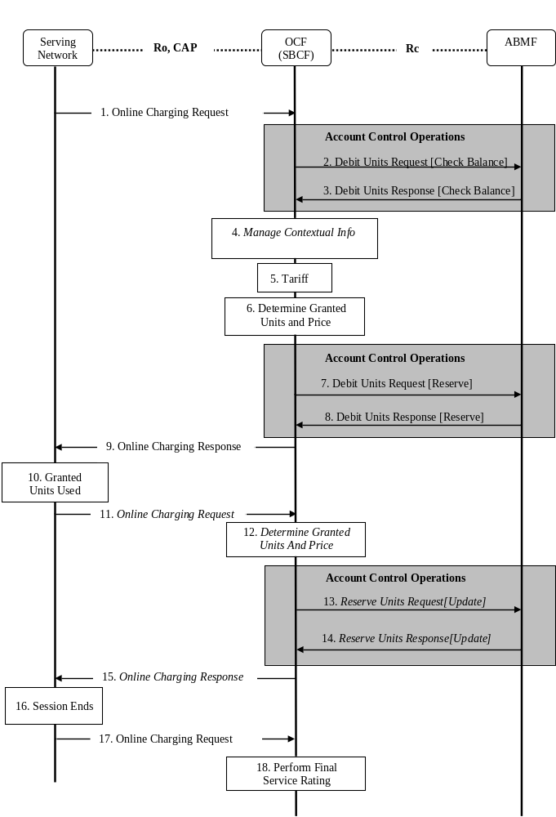
Figure B.3.3 - Session based Account Reservation with Debit or Release
Step 1: The SBCF receives an online charging request for a certain event/service.

Steps 2 through 5 relate to unit and price determination.

Step 2(Optional): The SBCF requests account and counter information for the subscriber from the Account Balance Management Function. Only valid for Rating class “A”.
Step 3(Optional): The SBCF receives account and counter information for the subscriber from the Account Balance Management Function. Only valid for Rating class “A”.
Step 4 (Optional): In case there is no existing subscriber's context, the SBCF creates a new subscriber's context information. Otherwise, the SBCF updates the existing subscriber's context and gets the list of active services for the given subscriber (see note below). This Step only applies when correlation is enabled.
Step 5: The SBCF determines the tariff for the requested service. This step particularly involves the Rating Function.
Step 6: The SBCF determines the granted units and price. The Rating Function is involved based on different circumstances and Rating class.
Step 7: The SBCF requests the ABMF to create reservations for the requested service.
Step 8: The SBCF receives the response to the request to create reservations for the requested service.
Step 9: The SBCF sends the appropriate online charging response, indicating granted units.
Step 10: The granted units are used as the service is delivered by the serving network or session parameters changed (e.g. QoS).

Steps 11 through 15 are optional and may repeat zero or more times.

Step 11: The serving network node sends an indication of the granted units’ usage to the SBCF.
Step 12: The SBCF determines the granted units and price. The Rating Function is involved based on different circumstances and Rating class.
Step 13: The SBCF requests the ABMF to update the reservation for the requested service.
Step 14: The SBCF receives the response to the request to update the reservation.
Step 15: Assuming account balance status is successful the granted units are acknowledged once again to the serving node in the network.
Step 16: The service session ends.
Step 17: The SBCF receives an online charging request.
Step 18: The SBCF performs final rating for the consumed session resources. The Rating Function is involved based on the Rating class.
Step 19: The SBCF requests the ABMF to debit the reservations for the delivered service. The debit value may be equal or lower than reserved value. Counters update is performed for Rating class “A”. If the service delivery fails the SBCF requests a reservation release.
Step 20: The ABMF responds to the debit or releaseoperation request.
Step 21: The SBCF sends the appropriate online charging response.

B.3.4 Account Refund
The following figure describes a Refund message flow when OCF interacts with an ABMF over an Rc reference point.

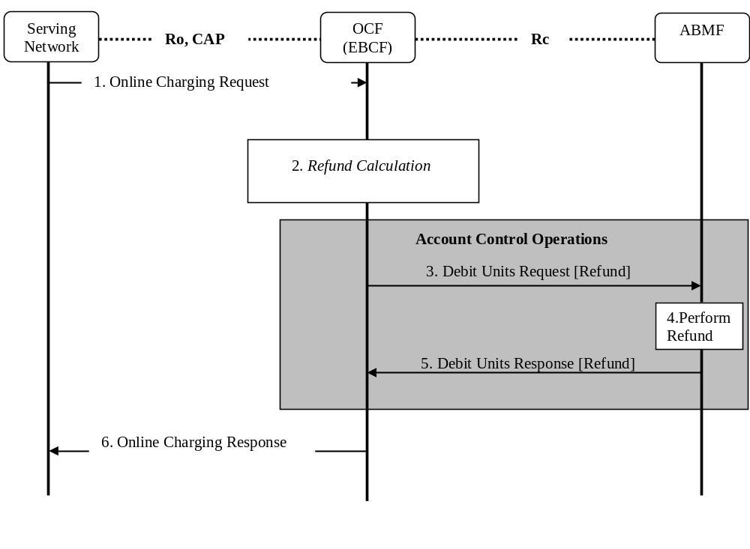
Figure B.3.4 – Account Refund Message flow
Step1: The EBCF receives an online charging request for a certain event/service.
Step2: The OCF calculates monetary and counters refund information. This step particularly involves the Rating Function.
Step 3: The OCF requests for refund from the ABMF using Debit Unit Request (Refund).
Step 4: The ABMF performs refund operation for the refunded service.
Step 5: The ABMF returns the result code to the OCF using Debit Unit Response (Refund).
Step 6: The EBCF sends the appropriate online charging response.

B.3.5 Balance Query
The following figure describes a Balance Query message flow when OCF interacts with an ABMF over an Rc reference point.
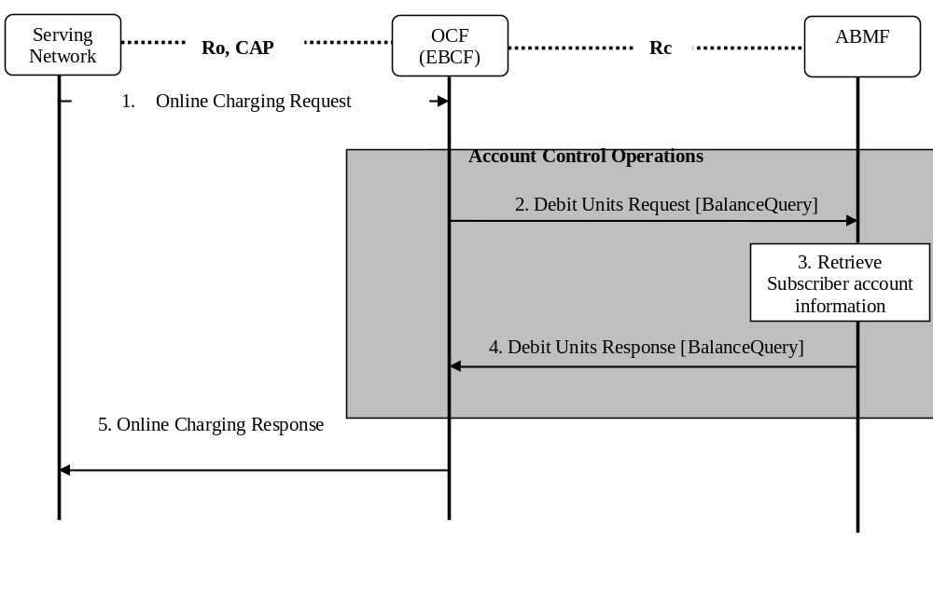Figure B.3.5 – Balance Query
Step 1: The EBCF receives an online charging request for balance query.
Step 2: The OCF requests for balance query of the subscriber’s account from the Account Balance Management Function using Debit Units Request (Balance Query).
Step 3: The ABMF retrieves the subscriber’s account balance
Step 4: The ABMF returns the account balance information to the OCF using Debit Units Response (Balance Query).
Step 5: The EBCF sends the appropriate online charging response.

B.4 Rc operation mapping to Diameter
The Rc functional operations are mapped to the Diameter protocol operations as follows. Debit Units Request will be implemented in Credit-Control-Request (CCR) and Debit Units Response in Credit-Control-Answer (CCA).
Rc operation | Diameter operation | Description
Immediate Account Debit | IEC | The credit control process for events is controlled by the Credit-Control-Request (CCR) with corresponding CC-Requested-Type EVENT_REQUEST.
Event based Account Debit with Reservation | ECUR | Event Charging with Unit Reservation is used for credit control sessions and uses the Credit-Control-Request (CCR) with CC-Request-Type INITIAL and TERMINATION_REQUEST.
Session based Account Debit with Reservation | SCUR | Session Charging with Unit Reservation is used for credit control sessions and uses the Credit-Control-Request (CCR) with CC-Request-Type INITIAL / UPDATE and TERMINATION_REQUEST.
Account Refund | IEC | Credit-Control-Request (CCR) with CC-Request-Type AVP set to EVENT_REQUEST to refund monetary units to the subscriber’s account. The Requested-Action AVP (RA) is set to REFUND_ACCOUNT.
Account Balance Query | IEC | Credit-Control-Request (CCR) with CC-Request-Type AVP set to EVENT_REQUEST to query the subscriber’s account. The Requested-Action AVP (RA) is set to BALANCE_CHECK.

B.5 Rc Diameter AVP Definitions
In order to provide a unified way for Rc implementation, the following guidance of credit control format is used for Rc reference point implementation.
NOTE: The AVP defnitions referred to in this clause are the same as in TS 32.299 [50], except when there is a specific definition.

B.5.1 Credit-Control-Request Message Syntax definition for Rc
The CCR messages, indicated by the Command-Code field set to 272 is sent by the OCF to the ABMF in order to request account credits for the request session based charging function, and event based charging function.
The CCR message format is defined according to IETF RFC 4006 [402] as follows:
<CCR> ::= < Diameter Header: 272, REQ, PXY >

< Session-Id >
{ Origin-Host }
{ Origin-Realm }
{ Destination-Realm }
{ Auth-Application-Id }
{ Service-Context-Id }
{ CC-Request-Type }
{ CC-Request-Number }
[ Destination-Host ]
[ User-Name ]
[ CC-Sub-Session-Id ]
[ Acct-Multi-Session-Id ]
[ Origin-State-Id ]
[ Event-Timestamp ]
*[ Subscription-Id ]
[ Service-Identifier ]
[ Termination-Cause ]
[ Requested-Service-Unit ]
[ Requested-Action ]
*[ Used-Service-Unit ]
[ AoC-Request-Type ]
[ Multiple-Services-Indicator ]
*[ Multiple-Services-Credit-Control ]
*[ Service-Parameter-Info ]
[ CC-Correlation-Id ]
[ User-Equipment-Info ]
*[ Proxy-Info ]
*[ Route-Record ]
[ Service-Information ]
*[ AVP ]

In the Rc Account debit request, the AVP definitions refer to TS 32.299 [50].

B.5.2 Credit-Control-Answer Message Syntax Definition for Rc
The Credit-Control-Answer (CCA) messages, indicated by the Command-Code field set to 272 is sent by the ABMF to the OCF in order to reply to the Rc request.
The CCA message format is defined according to IETF RFC 4006 [402] as follows:
<CCA> ::= < Diameter Header: 272, PXY >

< Session-Id >
{ Result-Code }
{ Origin-Host }
{ Origin-Realm }
{ Auth-Application-Id }
{ CC-Request-Type }
{ CC-Request-Number }
[ User-Name ]
[ CC-Session-Failover ]
[ CC-Sub-Session-Id ]
[ Acct-Multi-Session-Id ]
[ Origin-State-Id ]
[ Event-Timestamp ]
[ Granted-Service-Unit ]
*[ Multiple-Services-Credit-Control ]
[ Cost-Information]
[ Low-Balance-Indication ]
[ Remaining-Balance ]
[ AB-Response ]
[ Final-Unit-Indication ]
[ Check-Balance-Result ]
[ Credit-Control-Failure-Handling ]
[ Direct-Debiting-Failure-Handling ]
[ Validity-Time]
*[ Redirect-Host]
[ Redirect-Host-Usage ]
[ Redirect-Max-Cache-Time ]
*[ Proxy-Info ]
*[ Route-Record ]
*[ Failed-AVP ]
[ Service-Information ]
*[ AVP ]

In the Rc Account debit answer, the AVP definitions refer to TS 32.299 [50].

B.6 AVPs Description for the Rc Reference Point
In Rc Account Balance Request and Response message, the AVP definitions are same as in TS 32.299 [50], except there is definition in the present chapter.
Detailed descriptions of AVPs that are used specifically for account balance management are provided in the subclauses below the table. The table contains all AVPs used for the Diameter ABM application, in alphabetical order. For AVPs that are just borrowed from other applications only the reference is provided in the table below, and the detailed description is not repeated.
AVP Name | AVP Code | Data Type | Description / Reference
[ AB-Response ] | TBD | Grouped | Subclause B.6.1
* [ Acct-Balance ] | TBD | Group | Subclause B.6.2
[ Acct-Balance-Id ] | TBD | Unsigned64 | Subclause B.6.3
[ Unit-Value ] |  |  | Used as defined in DCCA [402].
[ Value-Digits ] |  |  | Used as defined in DCCA [402].
[ Exponent ] |  |  | Used as defined in DCCA [402].
* [ Counter ] | TBD | Grouped | Used as defined in subclause 7.1.4.2.9
{ CounterID } | TBD | Unsigned32 | Used as defined in subclause 7.1.4.2.20
[ CounterValue ] | TBD | Integer32 | Used as defined in subclause 7.1.4.2.25
[ CounterExpiryDate ] | TBD | Time | Used as defined in subclause 7.1.4.2.19

B.6.1 AB-Response AVP
The AB-Response AVP (AVP code XXXX) is of type Grouped. It contains information related to present information and counters information which stored in the ABMF.
The AB-Response AVP has the following format:
AB-Response:: = < AVP Header: TBD>
* [ Acct-Balance ]
* [ Counter ]

B.6.2 Acct-Balance AVP
The Acct-Balance AVP (AVP code XXXX) is of type Grouped. It contains information related to return specific account balance when a subscriber has multiple accounts. A subscriber may have multiple accounts assigned by operator, e.g. normal account, present account, etc.
The Acct-Balance AVP has the following format:
Acct-Balance:: = < AVP Header: TBD>
[ Acct-Balance-Id ]
[ Unit-Value ]
[ Value-Digits ]
[ Exponent ]

B.6.3 Acct-Balance-Id AVP
The Acct-Balance-Id AVP (AVP code XXXX) is of type Unsigned64. It uniquely identifies the account balance within the ABMF.

Annex C (informative):
Change history
Change history
Date | TSG # | TSG Doc. | CR | R | Subject/Comment | Old | New
Dec 2006 | SP-34 | SP-060714 | 0006 | -- | Update of Flow Based Charging for PCC - Align with 23.203 | 6.3.0 | 7.0.0
Sep 2007 | SP-37 | SP-070619 | 0006a | -- | Introduce online charging correlation | 7.0.0 | 8.0.0
Dec 2007 | SP-38 | SP-070746 | 0007 | -- | Clarifications on Online Charging correlation | 8.0.0 | 8.1.0
Jun 2008 | SP-40 | SP-080274 | 0008 | -- | Implication on Online Charging System (OCS) description for EPC Charging | 8.1.0 | 8.2.0
2009-01 |  |  |  |  | Editorial correction to preceding entry in history box;  LTE logo replaces GSM logo;  Keywords revised;  Copyright frame updated to current model | 8.2.0 | 8.2.1
2009-03 | SP-43 | SP-090203 | 0008a | -- | Advice of Charge (AoC) support in Online Charging System (OCS) | 8.2.1 | 8.3.0
2009-09 | SP-45 | SP-090537 | 0009 | -- | Updates to Account Related Definitions | 8.3.0 | 9.0.0
2009-12 | SP-46 | SP-090721 | 0010 | -- | Correction of Re application ID | 9.0.0 | 9.1.0
2010-03 | SP-47 | SP-100042 | 0011 | -- | Modify Scenario Descriptions | 9.1.0 | 10.0.0
2010-10 | SP-49 | SP-100500 | 0013 | -- | Creation Of An Informative Annex For Rc Operator Guidance | 10.0.0 | 10.1.0
2010-12 | SP-50 | SP-100758 | 0014 | 2 | Correction of price and tariff request scenarios | 10.1.0 | 10.2.0
2010-12 | SP-50 | SP-100759 | 0015 | 2 | Completion of informative Annex on Rc Reference Point Operator Guidance | 10.1.0 | 10.2.0
2011-03 | SP-51 | SP-110111 | 0018 | -- | Removal of incomplete description for solutions for Rc reference point | 10.2.0 | 10.3.0
2011-06 | SP-52 | SP-110317 | 0019 | 1 | Escalating output of Rel-10 to Rel-11 for CH-Rc | 10.3.0 | 11.0.0
2011-06 | SP-52 | SP-110317 | 0020 | 1 | AVP description for Rc | 10.3.0 | 11.0.0
2011-09 | SP-53 | SP-110542 | 0021 | 1 | Implication of Sy reference point on OCS architecture | 11.0.0 | 11.1.0
2011-12 | SP-54 | SP-110711 | 0022 | 3 | Editorial changes against Rc reference point | 11.1.0 | 11.2.0
2011-12 | SP-54 | SP-110711 | 0025 | 1 | Corrections to the Rc Reference Point Operator Guidance | 11.1.0 | 11.2.0
2011-12 | SP-54 | SP-110849 | 0023 | 1 | Function Definition of OCS for Sy | 11.1.0 | 11.2.0
2011-12 | SP-54 | SP-110849 | 0024 | 1 | Add Notification Management To The Required Functionality Of The OCS | 11.1.0 | 11.2.0
2012-03 | SP-55 | SP-120058 | 0027 | - | Correction on references for Sy interface | 11.2.0 | 11.3.0

